Haut du formulaire

[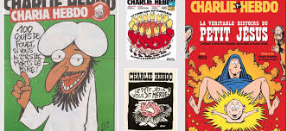](https://www.google.fr/imgres?imgurl=http://www.slate.fr/sites/default/files/styles/1090x500/public/caricatures-religions.jpg&imgrefurl=http://www.slate.fr/story/96583/caricature-religion&docid=LpV2PD29EuF29M&tbnid=MC3YUk7yRZniFM:&vet=10ahUKEwiW0ISlou_VAhUFJFAKHS9TBwMQMwg4KBIwEg..i&w=1090&h=500&client=firefox-b&bih=671&biw=1075&q=couverture%20anti-religieuse%20de%20charlie%20hebdo&ved=0ahUKEwiW0ISlou_VAhUFJFAKHS9TBwMQMwg4KBIwEg&iact=mrc&uact=8)

[](https://www.google.fr/imgres?imgurl=https://www.egaliteetreconciliation.fr/local/cache-vignettes/L650xH826/CH1031-01-c272d.jpg&imgrefurl=https://www.egaliteetreconciliation.fr/Tueur-de-Toulouse-Montauban-l-odieuse-Une-de-Charlie-Hebdo-10982.html&docid=TkHNv0qBXiOWXM&tbnid=uO3Iu4NF6SYbNM:&vet=10ahUKEwiW0ISlou_VAhUFJFAKHS9TBwMQMwg5KBMwEw..i&w=650&h=826&client=firefox-b&bih=671&biw=1075&q=couverture%20anti-religieuse%20de%20charlie%20hebdo&ved=0ahUKEwiW0ISlou_VAhUFJFAKHS9TBwMQMwg5KBMwEw&iact=mrc&uact=8)

[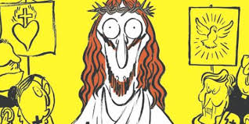](https://www.google.fr/imgres?imgurl=http://www.lepoint.fr/images/2012/09/20/charlie-hebdo-682792-jpg_468939_1250x625.JPG&imgrefurl=http://www.lepoint.fr/societe/charlie-hebdo-s-en-prend-il-a-toutes-les-religions-20-09-2012-1508355_23.php&docid=lQr_pyHcuBvyaM&tbnid=px753c50cjTjgM:&vet=10ahUKEwiW0ISlou_VAhUFJFAKHS9TBwMQMwhEKBQwFA..i&w=1250&h=625&client=firefox-b&bih=671&biw=1075&q=couverture%20anti-religieuse%20de%20charlie%20hebdo&ved=0ahUKEwiW0ISlou_VAhUFJFAKHS9TBwMQMwhEKBQwFA&iact=mrc&uact=8)

[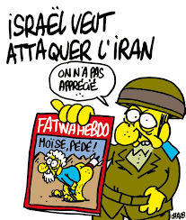](https://www.google.fr/imgres?imgurl=http://www.jewpop.com/wp-content/uploads/2011/11/392049_304149632945996_100000528857410_1153838_22450303_n.jpg&imgrefurl=http://jewpop.com/nous-sommes-tous-des-charlie-hebd/&docid=nj4jYUZKqJBShM&tbnid=IC5wFO2fwj5-mM:&vet=10ahUKEwiW0ISlou_VAhUFJFAKHS9TBwMQMwhFKBUwFQ..i&w=700&h=827&client=firefox-b&bih=671&biw=1075&q=couverture%20anti-religieuse%20de%20charlie%20hebdo&ved=0ahUKEwiW0ISlou_VAhUFJFAKHS9TBwMQMwhFKBUwFQ&iact=mrc&uact=8)

[](https://www.google.fr/imgres?imgurl=http://img.over-blog-kiwi.com/0/94/72/48/20160107/ob_be7c44_pour-charlie-hebdo-un-an-apres-l-atten.jpg&imgrefurl=http://www.caricaturesetcaricature.com/2016/01/et-l-assassin-court-toujours-le-dessin-de-riss-en-une-de-charlie-hebdo-6-janvier-2016.html&docid=_MbZsbmIbr_zQM&tbnid=C5ukVkM0RMupMM:&vet=10ahUKEwiW0ISlou_VAhUFJFAKHS9TBwMQMwhGKBYwFg..i&w=780&h=1040&client=firefox-b&bih=671&biw=1075&q=couverture%20anti-religieuse%20de%20charlie%20hebdo&ved=0ahUKEwiW0ISlou_VAhUFJFAKHS9TBwMQMwhGKBYwFg&iact=mrc&uact=8)

[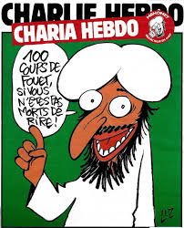](https://www.google.fr/imgres?imgurl=https://www.les-crises.fr/wp-content/uploads/2015/01/charlie-hebdo-01.jpg&imgrefurl=https://www.les-crises.fr/charlie-hebdo-pas-raciste-si-vous-le-dites-par-olivier-cyran/&docid=T3H0pxsOOpmbQM&tbnid=4Cmrq91J0_REPM:&vet=10ahUKEwiW0ISlou_VAhUFJFAKHS9TBwMQMwhHKBcwFw..i&w=680&h=840&client=firefox-b&bih=671&biw=1075&q=couverture%20anti-religieuse%20de%20charlie%20hebdo&ved=0ahUKEwiW0ISlou_VAhUFJFAKHS9TBwMQMwhHKBcwFw&iact=mrc&uact=8)

[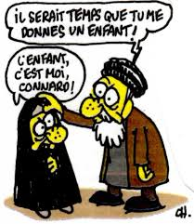](https://www.google.fr/imgres?imgurl=https://www.les-crises.fr/wp-content/uploads/2015/01/charlie-hebdo-07.jpg&imgrefurl=https://www.les-crises.fr/charlie-hebdo-pas-raciste-si-vous-le-dites-par-olivier-cyran/&docid=T3H0pxsOOpmbQM&tbnid=xZeIkc6IyN1KUM:&vet=10ahUKEwiW0ISlou_VAhUFJFAKHS9TBwMQMwhIKBgwGA..i&w=464&h=535&client=firefox-b&bih=671&biw=1075&q=couverture%20anti-religieuse%20de%20charlie%20hebdo&ved=0ahUKEwiW0ISlou_VAhUFJFAKHS9TBwMQMwhIKBgwGA&iact=mrc&uact=8)

[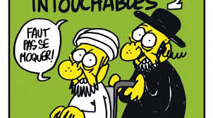](https://www.google.fr/imgres?imgurl=http://www.atlantico.fr/sites/atlantico.fr/files/styles/une/public/images/2014/04/une_charlie_hebdo.jpg&imgrefurl=http://www.atlantico.fr/atlantico-light/caricatures-mahomet-charlie-hebdo-en-remet-couche-gouvernement-inquiete-486595.html&docid=2OyBjOqpTMn-AM&tbnid=I0eecqO70kbNyM:&vet=10ahUKEwiW0ISlou_VAhUFJFAKHS9TBwMQMwhJKBkwGQ..i&w=662&h=366&client=firefox-b&bih=671&biw=1075&q=couverture%20anti-religieuse%20de%20charlie%20hebdo&ved=0ahUKEwiW0ISlou_VAhUFJFAKHS9TBwMQMwhJKBkwGQ&iact=mrc&uact=8)

[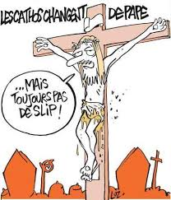](https://www.google.fr/imgres?imgurl=http://www.arretsurimages.net/media/breve/s185/id18400/original.77699.jpg&imgrefurl=http://www.disneycentralplaza.com/t46982p460-attentat-fusillade-chez-charlie-hebdo-a-paris&docid=fZnKChhPc8bdGM&tbnid=svyK5rjGdHX1qM:&vet=10ahUKEwiW0ISlou_VAhUFJFAKHS9TBwMQMwhKKBowGg..i&w=400&h=468&client=firefox-b&bih=671&biw=1075&q=couverture%20anti-religieuse%20de%20charlie%20hebdo&ved=0ahUKEwiW0ISlou_VAhUFJFAKHS9TBwMQMwhKKBowGg&iact=mrc&uact=8)

[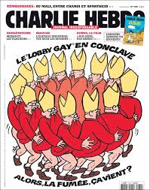](https://www.google.fr/imgres?imgurl=http://www.slate.fr/sites/default/files/photos/CH1080-01.jpg&imgrefurl=http://www.slate.fr/story/96543/unes-charlie-hebdo&docid=Z7KnHZI-Jnt16M&tbnid=LTzIs1t3hI07dM:&vet=10ahUKEwiW0ISlou_VAhUFJFAKHS9TBwMQMwhMKBwwHA..i&w=650&h=825&client=firefox-b&bih=671&biw=1075&q=couverture%20anti-religieuse%20de%20charlie%20hebdo&ved=0ahUKEwiW0ISlou_VAhUFJFAKHS9TBwMQMwhMKBwwHA&iact=mrc&uact=8)

[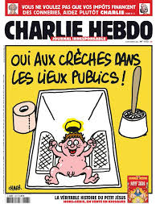](https://www.google.fr/imgres?imgurl=http://p1.storage.canalblog.com/19/22/177230/100853043_o.png&imgrefurl=http://stripsjournal.canalblog.com/tag/Les%20Unes%20de%20Charlie%20Hebdo/p80-0.html&docid=ncFirTAB4IAu7M&tbnid=ahDSIedeDyRRSM:&vet=10ahUKEwiW0ISlou_VAhUFJFAKHS9TBwMQMwhNKB0wHQ..i&w=590&h=750&client=firefox-b&bih=671&biw=1075&q=couverture%20anti-religieuse%20de%20charlie%20hebdo&ved=0ahUKEwiW0ISlou_VAhUFJFAKHS9TBwMQMwhNKB0wHQ&iact=mrc&uact=8)

[](https://www.google.fr/imgres?imgurl=http://www.lexpress.fr/medias/2155/1103595.jpg&imgrefurl=http://www.lexpress.fr/actualite/societe/en-direct-caricatures-de-charlie-hebdo-et-film-anti-islam-tensions-dans-les-monde-musulman-en-ce-jour-de-priere_1164128.html&docid=J7mtdMFG_vu0cM&tbnid=6rbqNEK5zziMAM:&vet=10ahUKEwiW0ISlou_VAhUFJFAKHS9TBwMQMwhOKB4wHg..i&w=400&h=270&client=firefox-b&bih=671&biw=1075&q=couverture%20anti-religieuse%20de%20charlie%20hebdo&ved=0ahUKEwiW0ISlou_VAhUFJFAKHS9TBwMQMwhOKB4wHg&iact=mrc&uact=8)

[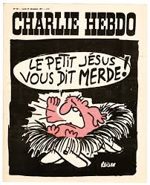](https://www.google.fr/imgres?imgurl=http://www.slate.fr/sites/default/files/photos/10436258_413552235466130_2976431115470626194_n(1).jpg&imgrefurl=http://www.slate.fr/story/96583/caricature-religion&docid=LpV2PD29EuF29M&tbnid=GKbu_MCJmlethM:&vet=10ahUKEwiW0ISlou_VAhUFJFAKHS9TBwMQMwhPKB8wHw..i&w=591&h=728&client=firefox-b&bih=671&biw=1075&q=couverture%20anti-religieuse%20de%20charlie%20hebdo&ved=0ahUKEwiW0ISlou_VAhUFJFAKHS9TBwMQMwhPKB8wHw&iact=mrc&uact=8)

[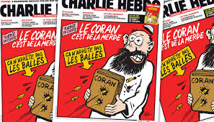](https://www.google.fr/imgres?imgurl=http://www.ojim.fr/wp-content/uploads/2013/11/coran-merde-charlie-hebdo-karim-achoui-balles.jpg&imgrefurl=http://www.panamza.com/20112013-charlie-hebdo-raciste/&docid=cuvTBwwuDh2i3M&tbnid=-tQ36qGEosnPcM:&vet=10ahUKEwiW0ISlou_VAhUFJFAKHS9TBwMQMwhQKCAwIA..i&w=700&h=400&client=firefox-b&bih=671&biw=1075&q=couverture%20anti-religieuse%20de%20charlie%20hebdo&ved=0ahUKEwiW0ISlou_VAhUFJFAKHS9TBwMQMwhQKCAwIA&iact=mrc&uact=8)

[[](https://www.google.fr/imgres?imgurl=https://img15.hostingpics.net/pics/139457DH1yK8iWsAAnm1h.jpg&imgrefurl=http://www.fdesouche.com/877875-islam-religion-de-paix-eternelle-de-charlie-hebdo-lattentat-de-barcelone&docid=HFZppzASmvTeFM&tbnid=IwIDhcoeRUOu2M:&vet=10ahUKEwiW0ISlou_VAhUFJFAKHS9TBwMQMwhRKCEwIQ..i&w=884&h=1200&client=firefox-b&bih=671&biw=1075&q=couverture%20anti-religieuse%20de%20charlie%20hebdo&ved=0ahUKEwiW0ISlou_VAhUFJFAKHS9TBwMQMwhRKCEwIQ&iact=mrc&uact=8)](https://www.google.fr/imgres?imgurl=https%3A%2F%2Fimg15.hostingpics.net%2Fpics%2F139457DH1yK8iWsAAnm1h.jpg&imgrefurl=http%3A%2F%2Fwww.fdesouche.com%2F877875-islam-religion-de-paix-eternelle-de-charlie-hebdo-lattentat-de-barcelone&docid=HFZppzASmvTeFM&tbnid=IwIDhcoeRUOu2M%3A&vet=10ahUKEwiW0ISlou_VAhUFJFAKHS9TBwMQMwhRKCEwIQ..i&w=884&h=1200&client=firefox-b&bih=671&biw=1075&q=couverture%20anti-religieuse%20de%20charlie%20hebdo&ved=0ahUKEwiW0ISlou_VAhUFJFAKHS9TBwMQMwhRKCEwIQ&iact=mrc&uact=8)

[il y a 1 jour](https://www.google.fr/imgres?imgurl=https%3A%2F%2Fimg15.hostingpics.net%2Fpics%2F139457DH1yK8iWsAAnm1h.jpg&imgrefurl=http%3A%2F%2Fwww.fdesouche.com%2F877875-islam-religion-de-paix-eternelle-de-charlie-hebdo-lattentat-de-barcelone&docid=HFZppzASmvTeFM&tbnid=IwIDhcoeRUOu2M%3A&vet=10ahUKEwiW0ISlou_VAhUFJFAKHS9TBwMQMwhRKCEwIQ..i&w=884&h=1200&client=firefox-b&bih=671&biw=1075&q=couverture%20anti-religieuse%20de%20charlie%20hebdo&ved=0ahUKEwiW0ISlou_VAhUFJFAKHS9TBwMQMwhRKCEwIQ&iact=mrc&uact=8)

[](https://www.google.fr/imgres?imgurl=https://www.les-crises.fr/wp-content/uploads/2015/01/charlie-hebdo-05.jpg&imgrefurl=https://www.les-crises.fr/charlie-hebdo-pas-raciste-si-vous-le-dites-par-olivier-cyran/&docid=T3H0pxsOOpmbQM&tbnid=AIVDD2rTibuh4M:&vet=10ahUKEwiW0ISlou_VAhUFJFAKHS9TBwMQMwhTKCIwIg..i&w=571&h=398&client=firefox-b&bih=671&biw=1075&q=couverture%20anti-religieuse%20de%20charlie%20hebdo&ved=0ahUKEwiW0ISlou_VAhUFJFAKHS9TBwMQMwhTKCIwIg&iact=mrc&uact=8)

[](https://www.google.fr/imgres?imgurl=http://bigbrowser.blog.lemonde.fr/files/2015/02/000_Par6631016.jpg&imgrefurl=http://bigbrowser.blog.lemonde.fr/2015/02/01/luz-la-majorite-des-musulmans-sen-foutent-de-charlie-hebdo/&docid=3CvTXbpFAni2SM&tbnid=s6RswVjhfIH6BM:&vet=10ahUKEwiW0ISlou_VAhUFJFAKHS9TBwMQMwhUKCMwIw..i&w=4256&h=2832&client=firefox-b&bih=671&biw=1075&q=couverture%20anti-religieuse%20de%20charlie%20hebdo&ved=0ahUKEwiW0ISlou_VAhUFJFAKHS9TBwMQMwhUKCMwIw&iact=mrc&uact=8)

[](https://www.google.fr/imgres?imgurl=https://www.les-crises.fr/wp-content/uploads/2015/01/charlie-hebdo-06.jpg&imgrefurl=https://www.les-crises.fr/charlie-hebdo-pas-raciste-si-vous-le-dites-par-olivier-cyran/&docid=T3H0pxsOOpmbQM&tbnid=0gwfUlTK8TdpoM:&vet=10ahUKEwiW0ISlou_VAhUFJFAKHS9TBwMQMwhVKCQwJA..i&w=550&h=551&client=firefox-b&bih=671&biw=1075&q=couverture%20anti-religieuse%20de%20charlie%20hebdo&ved=0ahUKEwiW0ISlou_VAhUFJFAKHS9TBwMQMwhVKCQwJA&iact=mrc&uact=8)

[](https://www.google.fr/imgres?imgurl=http://static.lexpress.fr/medias_10577/w_494,h_276,c_crop,x_0,y_32/w_640,h_360,c_fill,g_north/v1442322474/charlie-hebdo-14_5415537.jpg&imgrefurl=http://www.lexpress.fr/actualite/medias/les-anti-charlie-hebdo-s-offusquent-des-caricatures-du-petit-aylan_1715968.html&docid=4Ll4jIQdNHQpXM&tbnid=5Nbkq7imIQqY0M:&vet=10ahUKEwiW0ISlou_VAhUFJFAKHS9TBwMQMwhWKCUwJQ..i&w=640&h=360&client=firefox-b&bih=671&biw=1075&q=couverture%20anti-religieuse%20de%20charlie%20hebdo&ved=0ahUKEwiW0ISlou_VAhUFJFAKHS9TBwMQMwhWKCUwJQ&iact=mrc&uact=8)

[](https://www.google.fr/imgres?imgurl=http://www.peripheries.net/IMG/jpg/Femen.jpg&imgrefurl=http://www.peripheries.net/article335.html&docid=7mLzOu1gYVeQbM&tbnid=Vz1MFtFxxUUOHM:&vet=10ahUKEwiW0ISlou_VAhUFJFAKHS9TBwMQMwhXKCYwJg..i&w=400&h=294&client=firefox-b&bih=671&biw=1075&q=couverture%20anti-religieuse%20de%20charlie%20hebdo&ved=0ahUKEwiW0ISlou_VAhUFJFAKHS9TBwMQMwhXKCYwJg&iact=mrc&uact=8)

[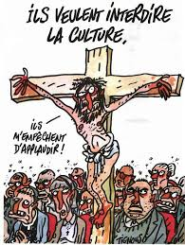](https://www.google.fr/imgres?imgurl=http://p7.storage.canalblog.com/71/65/177230/108260006.jpg&imgrefurl=http://stripsjournal.canalblog.com/tag/proph%C3%A8te/p10-0.html&docid=gYtowd8249DUrM&tbnid=SMpNUYZ_-iV4wM:&vet=10ahUKEwiW0ISlou_VAhUFJFAKHS9TBwMQMwhYKCcwJw..i&w=571&h=759&client=firefox-b&bih=671&biw=1075&q=couverture%20anti-religieuse%20de%20charlie%20hebdo&ved=0ahUKEwiW0ISlou_VAhUFJFAKHS9TBwMQMwhYKCcwJw&iact=mrc&uact=8)

[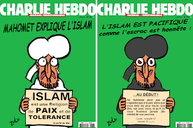](https://www.google.fr/imgres?imgurl=https://sitamnesty.files.wordpress.com/2015/01/couverture-charlie-hebdo_mahomet_tout-est-pardonne_couverture-hebdo-charlie_tout-pardonne-est_mahomet_pardonne-tout-est_charlie-couverture-hebdo_mahomet.png&imgrefurl=https://sitamnesty.wordpress.com/2015/01/14/mahomet-explique-lislam-en-une-de-charlie-hebdo/&docid=ySX0CwKyYqdcOM&tbnid=XStnq0uT-8SL1M:&vet=10ahUKEwiW0ISlou_VAhUFJFAKHS9TBwMQMwhZKCgwKA..i&w=1210&h=803&client=firefox-b&bih=671&biw=1075&q=couverture%20anti-religieuse%20de%20charlie%20hebdo&ved=0ahUKEwiW0ISlou_VAhUFJFAKHS9TBwMQMwhZKCgwKA&iact=mrc&uact=8)

[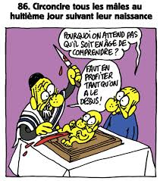](https://www.google.fr/imgres?imgurl=http://p9.storage.canalblog.com/97/33/177230/84461165_o.jpg&imgrefurl=http://stripsjournal.canalblog.com/tag/religion/p110-0.html&docid=ZmkeYk1IaU5dDM&tbnid=8DRZlCEpeM_xRM:&vet=10ahUKEwiW0ISlou_VAhUFJFAKHS9TBwMQMwhaKCkwKQ..i&w=580&h=655&client=firefox-b&bih=671&biw=1075&q=couverture%20anti-religieuse%20de%20charlie%20hebdo&ved=0ahUKEwiW0ISlou_VAhUFJFAKHS9TBwMQMwhaKCkwKQ&iact=mrc&uact=8)

[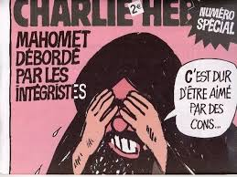](https://www.google.fr/imgres?imgurl=http://i.huffpost.com/gen/2461950/original.jpg&imgrefurl=http://www.huffingtonpost.fr/2015/01/07/charlie-hebdo-caricatures-mahomet-terrorisme_n_6428756.html&docid=EOKPA098K8_6UM&tbnid=TLfz3Nj2OChetM:&vet=10ahUKEwiW0ISlou_VAhUFJFAKHS9TBwMQMwhcKCswKw..i&w=640&h=480&client=firefox-b&bih=671&biw=1075&q=couverture%20anti-religieuse%20de%20charlie%20hebdo&ved=0ahUKEwiW0ISlou_VAhUFJFAKHS9TBwMQMwhcKCswKw&iact=mrc&uact=8)

[](https://www.google.fr/imgres?imgurl=https://www.egaliteetreconciliation.fr/IMG/jpg/talmud-magique-646x913.jpg&imgrefurl=http://www.egaliteetreconciliation.fr/Shoah-Hebdo-le-Talmud-c-est-magique-19043.html&docid=z-SIQxdN-_WqHM&tbnid=0_xmZfgSCYJFCM:&vet=10ahUKEwiW0ISlou_VAhUFJFAKHS9TBwMQMwhdKCwwLA..i&w=646&h=913&client=firefox-b&bih=671&biw=1075&q=couverture%20anti-religieuse%20de%20charlie%20hebdo&ved=0ahUKEwiW0ISlou_VAhUFJFAKHS9TBwMQMwhdKCwwLA&iact=mrc&uact=8)

[](https://www.google.fr/imgres?imgurl=http://static.lexpress.fr/medias_10726/w_521,h_291,c_crop,x_0,y_107/w_640,h_360,c_fill,g_north/v1451908994/charlie-hebdo-un-an-apres_5492124.jpeg&imgrefurl=http://www.lexpress.fr/actualite/medias/toutes-les-religions-s-indignent-de-sa-une-charlie-hebdo-est-de-retour_1750282.html&docid=hl_yidR1J4CGIM&tbnid=kXzA1cDAn4YP7M:&vet=10ahUKEwiW0ISlou_VAhUFJFAKHS9TBwMQMwhfKC4wLg..i&w=640&h=360&client=firefox-b&bih=671&biw=1075&q=couverture%20anti-religieuse%20de%20charlie%20hebdo&ved=0ahUKEwiW0ISlou_VAhUFJFAKHS9TBwMQMwhfKC4wLg&iact=mrc&uact=8)

[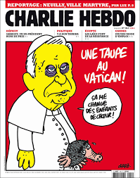](https://www.google.fr/imgres?imgurl=http://p5.storage.canalblog.com/55/56/177230/76166756.jpg&imgrefurl=http://stripsjournal.canalblog.com/archives/charb/p110-0.html&docid=AcpkwkQ3f4FfvM&tbnid=Dcb627jgvEbyuM:&vet=10ahUKEwiW0ISlou_VAhUFJFAKHS9TBwMQMwhiKDEwMQ..i&w=630&h=800&client=firefox-b&bih=671&biw=1075&q=couverture%20anti-religieuse%20de%20charlie%20hebdo&ved=0ahUKEwiW0ISlou_VAhUFJFAKHS9TBwMQMwhiKDEwMQ&iact=mrc&uact=8)

[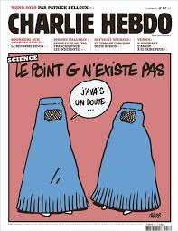](https://www.google.fr/imgres?imgurl=https://i.pinimg.com/736x/bc/eb/33/bceb33e3ec284c859fb821fd3bf07390--le-point-je-suis-charlie.jpg&imgrefurl=https://fr.pinterest.com/explore/couverture-charlie-hebdo/&docid=q4FQX69Ia5c-AM&tbnid=fzPfRyQc61puMM:&vet=10ahUKEwiW0ISlou_VAhUFJFAKHS9TBwMQMwhjKDIwMg..i&w=600&h=776&client=firefox-b&bih=671&biw=1075&q=couverture%20anti-religieuse%20de%20charlie%20hebdo&ved=0ahUKEwiW0ISlou_VAhUFJFAKHS9TBwMQMwhjKDIwMg&iact=mrc&uact=8)

[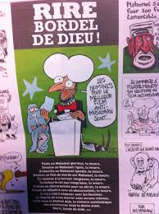](https://www.google.fr/imgres?imgurl=https://hichamhamza.files.wordpress.com/2012/09/charlie.jpg&imgrefurl=https://hichamhamza.wordpress.com/2012/09/20/lexpress-charlie-hebdo-censure/&docid=0dl0Mp1qPNYFVM&tbnid=elcdt4t8y9gmRM:&vet=10ahUKEwiW0ISlou_VAhUFJFAKHS9TBwMQMwhkKDMwMw..i&w=1936&h=2592&client=firefox-b&bih=671&biw=1075&q=couverture%20anti-religieuse%20de%20charlie%20hebdo&ved=0ahUKEwiW0ISlou_VAhUFJFAKHS9TBwMQMwhkKDMwMw&iact=mrc&uact=8)

[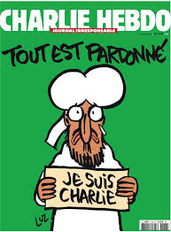](https://www.google.fr/imgres?imgurl=https://www.les-crises.fr/wp-content/uploads/2015/01/charlie-hebdo-83.jpg&imgrefurl=https://www.les-crises.fr/troubles-dessinateur-reagit/&docid=4SIk6Ug_2L5USM&tbnid=cRntew8H3S9PSM:&vet=10ahUKEwiW0ISlou_VAhUFJFAKHS9TBwMQMwhoKDcwNw..i&w=624&h=847&client=firefox-b&bih=671&biw=1075&q=couverture%20anti-religieuse%20de%20charlie%20hebdo&ved=0ahUKEwiW0ISlou_VAhUFJFAKHS9TBwMQMwhoKDcwNw&iact=mrc&uact=8)

[[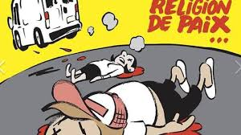](https://www.google.fr/imgres?imgurl=http://photos.lci.fr/images/656/369/charlie-hebdo-une-5d4ae3-0@1x.jpeg&imgrefurl=http://www.lci.fr/france/la-une-de-charlie-hebdo-consacree-aux-attentats-en-catalogne-accusee-sur-twitter-d-amalgame-entre-islam-et-terrorisme-2062073.html&docid=6iOzcW2IvvOLKM&tbnid=WLbSRk6JZjajTM:&vet=10ahUKEwiW0ISlou_VAhUFJFAKHS9TBwMQMwhrKDowOg..i&w=656&h=369&client=firefox-b&bih=671&biw=1075&q=couverture%20anti-religieuse%20de%20charlie%20hebdo&ved=0ahUKEwiW0ISlou_VAhUFJFAKHS9TBwMQMwhrKDowOg&iact=mrc&uact=8)](https://www.google.fr/imgres?imgurl=http%3A%2F%2Fphotos.lci.fr%2Fimages%2F656%2F369%2Fcharlie-hebdo-une-5d4ae3-0%401x.jpeg&imgrefurl=http%3A%2F%2Fwww.lci.fr%2Ffrance%2Fla-une-de-charlie-hebdo-consacree-aux-attentats-en-catalogne-accusee-sur-twitter-d-amalgame-entre-islam-et-terrorisme-2062073.html&docid=6iOzcW2IvvOLKM&tbnid=WLbSRk6JZjajTM%3A&vet=10ahUKEwiW0ISlou_VAhUFJFAKHS9TBwMQMwhrKDowOg..i&w=656&h=369&client=firefox-b&bih=671&biw=1075&q=couverture%20anti-religieuse%20de%20charlie%20hebdo&ved=0ahUKEwiW0ISlou_VAhUFJFAKHS9TBwMQMwhrKDowOg&iact=mrc&uact=8)

[il y a 1 jour](https://www.google.fr/imgres?imgurl=http%3A%2F%2Fphotos.lci.fr%2Fimages%2F656%2F369%2Fcharlie-hebdo-une-5d4ae3-0%401x.jpeg&imgrefurl=http%3A%2F%2Fwww.lci.fr%2Ffrance%2Fla-une-de-charlie-hebdo-consacree-aux-attentats-en-catalogne-accusee-sur-twitter-d-amalgame-entre-islam-et-terrorisme-2062073.html&docid=6iOzcW2IvvOLKM&tbnid=WLbSRk6JZjajTM%3A&vet=10ahUKEwiW0ISlou_VAhUFJFAKHS9TBwMQMwhrKDowOg..i&w=656&h=369&client=firefox-b&bih=671&biw=1075&q=couverture%20anti-religieuse%20de%20charlie%20hebdo&ved=0ahUKEwiW0ISlou_VAhUFJFAKHS9TBwMQMwhrKDowOg&iact=mrc&uact=8)

[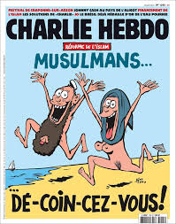](https://www.google.fr/imgres?imgurl=https://i.redd.it/qvw2r8jroeex.jpg&imgrefurl=https://www.reddit.com/r/france/comments/4wxxkn/la_couverture_de_charlie_hebdo_va_encore_faire/&docid=ZNI7QUojU1lH6M&tbnid=thWrDwyoip-aLM:&vet=10ahUKEwiW0ISlou_VAhUFJFAKHS9TBwMQMwhuKDwwPA..i&w=756&h=960&client=firefox-b&bih=671&biw=1075&q=couverture%20anti-religieuse%20de%20charlie%20hebdo&ved=0ahUKEwiW0ISlou_VAhUFJFAKHS9TBwMQMwhuKDwwPA&iact=mrc&uact=8)

[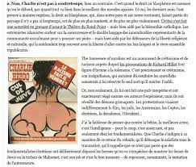](https://www.google.fr/imgres?imgurl=https://hichamhamza.files.wordpress.com/2012/09/capt-ecran-bis.jpg&imgrefurl=https://hichamhamza.wordpress.com/2012/09/20/lexpress-charlie-hebdo-censure/&docid=0dl0Mp1qPNYFVM&tbnid=xpaIlbCamnRl7M:&vet=10ahUKEwiW0ISlou_VAhUFJFAKHS9TBwMQMwhvKD0wPQ..i&w=676&h=575&client=firefox-b&bih=671&biw=1075&q=couverture%20anti-religieuse%20de%20charlie%20hebdo&ved=0ahUKEwiW0ISlou_VAhUFJFAKHS9TBwMQMwhvKD0wPQ&iact=mrc&uact=8)

[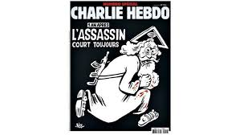](https://www.google.fr/imgres?imgurl=http://i.f1g.fr/media/figaro/805x453_crop/2016/01/04/XVMdc3cf178-b2ce-11e5-b5b5-ccb2324453c0.jpg&imgrefurl=http://www.lefigaro.fr/culture/2016/01/04/03004-20160104ARTFIG00104--charlie-hebdo-la-une-du-numero-special-fait-deja-polemique.php&docid=GjNGQEea6UnzoM&tbnid=PTvlRfvtRV9nzM:&vet=10ahUKEwiW0ISlou_VAhUFJFAKHS9TBwMQMwhwKD4wPg..i&w=805&h=453&client=firefox-b&bih=671&biw=1075&q=couverture%20anti-religieuse%20de%20charlie%20hebdo&ved=0ahUKEwiW0ISlou_VAhUFJFAKHS9TBwMQMwhwKD4wPg&iact=mrc&uact=8)

[](https://www.google.fr/imgres?imgurl=http://p3.storage.canalblog.com/31/59/177230/87240743_o.jpg&imgrefurl=http://stripsjournal.canalblog.com/tag/proph%C3%A8te/p10-0.html&docid=gYtowd8249DUrM&tbnid=fqRccjOZon2yMM:&vet=10ahUKEwiW0ISlou_VAhUFJFAKHS9TBwMQMwhxKD8wPw..i&w=650&h=682&client=firefox-b&bih=671&biw=1075&q=couverture%20anti-religieuse%20de%20charlie%20hebdo&ved=0ahUKEwiW0ISlou_VAhUFJFAKHS9TBwMQMwhxKD8wPw&iact=mrc&uact=8)

[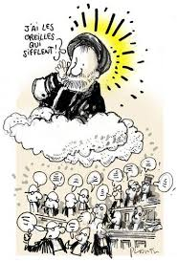](https://www.google.fr/imgres?imgurl=http://prdchroniques.blog.lemonde.fr/files/2007/03/mahomet.1174562639.thumbnail.jpg&imgrefurl=http://prdchroniques.blog.lemonde.fr/2007/03/22/attendu-que-charlie-hebdo-est-un-journal-satirique/&docid=THVbuACcvsyonM&tbnid=hnEgnfyNpBT_dM:&vet=10ahUKEwiW0ISlou_VAhUFJFAKHS9TBwMQMwhyKEAwQA..i&w=354&h=523&client=firefox-b&bih=671&biw=1075&q=couverture%20anti-religieuse%20de%20charlie%20hebdo&ved=0ahUKEwiW0ISlou_VAhUFJFAKHS9TBwMQMwhyKEAwQA&iact=mrc&uact=8)

[](https://www.google.fr/imgres?imgurl=https://s-media-cache-ak0.pinimg.com/736x/20/2d/c4/202dc41dc3166460046c3ba228cb286e--je-suis-charlie-charlie-hebdo.jpg&imgrefurl=https://www.pinterest.com/pin/304626362277996194/&docid=0jv8fZvCcP_EeM&tbnid=3iXJasZB4nQyeM:&vet=10ahUKEwiW0ISlou_VAhUFJFAKHS9TBwMQMwhzKEEwQQ..i&w=650&h=826&client=firefox-b&bih=671&biw=1075&q=couverture%20anti-religieuse%20de%20charlie%20hebdo&ved=0ahUKEwiW0ISlou_VAhUFJFAKHS9TBwMQMwhzKEEwQQ&iact=mrc&uact=8)

[](https://www.google.fr/imgres?imgurl=https://www.causeur.fr/wp-content/uploads/2015/01/vadot10.gif&imgrefurl=https://www.causeur.fr/charlie-hebdo-quelques-tweets-30946&docid=UUQmGEHK9jrBrM&tbnid=F4DMAKVo9BKL-M:&vet=10ahUKEwiW0ISlou_VAhUFJFAKHS9TBwMQMwh0KEIwQg..i&w=322&h=400&client=firefox-b&bih=671&biw=1075&q=couverture%20anti-religieuse%20de%20charlie%20hebdo&ved=0ahUKEwiW0ISlou_VAhUFJFAKHS9TBwMQMwh0KEIwQg&iact=mrc&uact=8)

[](https://www.google.fr/imgres?imgurl=http://3.bp.blogspot.com/-NxYflvUUuUI/VMwdUwqi5hI/AAAAAAAAA-k/v1Zw5rk2rJs/s1600/D'accord.jpg&imgrefurl=http://francisbrasilis.blogspot.com/2015/01/nous-sommes-charlie.html&docid=VJK1jCRamWtdLM&tbnid=vQuFstQT5CIJiM:&vet=10ahUKEwiW0ISlou_VAhUFJFAKHS9TBwMQMwh1KEMwQw..i&w=675&h=675&client=firefox-b&bih=671&biw=1075&q=couverture%20anti-religieuse%20de%20charlie%20hebdo&ved=0ahUKEwiW0ISlou_VAhUFJFAKHS9TBwMQMwh1KEMwQw&iact=mrc&uact=8)

[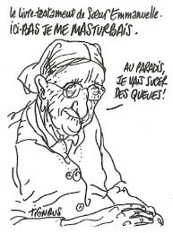](https://www.google.fr/imgres?imgurl=https://www.les-crises.fr/wp-content/uploads/2015/01/charlie-hebdo-14-01-2015-01.jpg&imgrefurl=https://www.les-crises.fr/troubles-dessinateur-reagit/&docid=4SIk6Ug_2L5USM&tbnid=aZdnzrYotsoPuM:&vet=10ahUKEwiW0ISlou_VAhUFJFAKHS9TBwMQMwh2KEQwRA..i&w=382&h=514&client=firefox-b&bih=671&biw=1075&q=couverture%20anti-religieuse%20de%20charlie%20hebdo&ved=0ahUKEwiW0ISlou_VAhUFJFAKHS9TBwMQMwh2KEQwRA&iact=mrc&uact=8)

[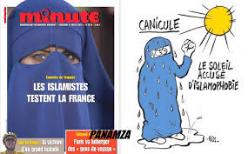](https://www.google.fr/imgres?imgurl=http://www.panamza.com/wp-content/uploads/2013/11/965742_270781873062516_838574831_o-1024x634.jpg&imgrefurl=http://www.panamza.com/20112013-charlie-hebdo-raciste/&docid=cuvTBwwuDh2i3M&tbnid=nitDMPFVe-hWpM:&vet=10ahUKEwiW0ISlou_VAhUFJFAKHS9TBwMQMwh3KEUwRQ..i&w=1024&h=634&client=firefox-b&bih=671&biw=1075&q=couverture%20anti-religieuse%20de%20charlie%20hebdo&ved=0ahUKEwiW0ISlou_VAhUFJFAKHS9TBwMQMwh3KEUwRQ&iact=mrc&uact=8)

[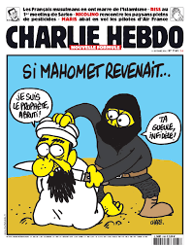](https://www.google.fr/imgres?imgurl=http://www.eclatsdeguerre.com/wp-content/uploads/2015/01/mahomet-revenait.jpg&imgrefurl=http://forum.hardware.fr/hfr/Discussions/Actualite/charlie-attentats-polemiques-sujet_61939_2706.htm&docid=wxhb4-7PG3lsTM&tbnid=01Xox7nqBtWFrM:&vet=10ahUKEwiW0ISlou_VAhUFJFAKHS9TBwMQMwh5KEcwRw..i&w=650&h=823&client=firefox-b&bih=671&biw=1075&q=couverture%20anti-religieuse%20de%20charlie%20hebdo&ved=0ahUKEwiW0ISlou_VAhUFJFAKHS9TBwMQMwh5KEcwRw&iact=mrc&uact=8)

[](https://www.google.fr/imgres?imgurl=https://sitamnesty.files.wordpress.com/2015/01/couverture_charlie-hebdo_mahomet_tout-est-pardonne_l-islam-est-une-religion-de-paix-et-de-tolerance_recto300.png?w=300&h=401&imgrefurl=https://sitamnesty.wordpress.com/2015/01/&docid=T-XvKydwOmy80M&tbnid=KJkQtQX1sR6NxM:&vet=10ahUKEwiW0ISlou_VAhUFJFAKHS9TBwMQMwh7KEkwSQ..i&w=300&h=401&client=firefox-b&bih=671&biw=1075&q=couverture%20anti-religieuse%20de%20charlie%20hebdo&ved=0ahUKEwiW0ISlou_VAhUFJFAKHS9TBwMQMwh7KEkwSQ&iact=mrc&uact=8)

[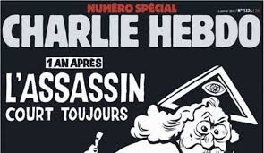](https://www.google.fr/imgres?imgurl=http://static.lexpress.fr/medias_10726/w_521,h_391,c_crop,x_0,y_0/w_605,h_350,c_fill,g_north/v1451908994/charlie-hebdo-un-an-apres_5492124.jpeg&imgrefurl=http://www.lexpress.fr/actualite/medias/toutes-les-religions-s-indignent-de-sa-une-charlie-hebdo-est-de-retour_1750282.html&docid=hl_yidR1J4CGIM&tbnid=VOJTWL8kgZI4DM:&vet=10ahUKEwiW0ISlou_VAhUFJFAKHS9TBwMQMwh9KEswSw..i&w=605&h=350&client=firefox-b&bih=671&biw=1075&q=couverture%20anti-religieuse%20de%20charlie%20hebdo&ved=0ahUKEwiW0ISlou_VAhUFJFAKHS9TBwMQMwh9KEswSw&iact=mrc&uact=8)

[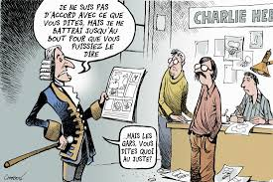](https://www.google.fr/imgres?imgurl=https://www.les-crises.fr/wp-content/uploads/2015/01/charlie-hebdo-15.jpg&imgrefurl=https://www.les-crises.fr/charlie-hebdo-pas-raciste-si-vous-le-dites-par-olivier-cyran/&docid=T3H0pxsOOpmbQM&tbnid=Y7OXlBAHSxquOM:&vet=10ahUKEwiW0ISlou_VAhUFJFAKHS9TBwMQMwiAAShOME4..i&w=550&h=367&itg=1&client=firefox-b&bih=671&biw=1075&q=couverture%20anti-religieuse%20de%20charlie%20hebdo&ved=0ahUKEwiW0ISlou_VAhUFJFAKHS9TBwMQMwiAAShOME4&iact=mrc&uact=8)

[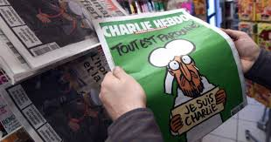](https://www.google.fr/imgres?imgurl=https://o.aolcdn.com/images/dims3/GLOB/legacy_thumbnail/1200x630/format/jpg/quality/85/http://i.huffpost.com/gen/2492932/images/n-CHARLIE-HEBDO-628x314.jpg&imgrefurl=http://www.huffingtonpost.fr/2015/01/14/critique-representants-musulmans-couverture-charlie-hebdo-opinion-malek-chebel_n_6472838.html&docid=izkD3a5ol9GwXM&tbnid=53ZNp7FXTkNUxM:&vet=10ahUKEwiW0ISlou_VAhUFJFAKHS9TBwMQMwiBAShPME8..i&w=1200&h=630&client=firefox-b&bih=671&biw=1075&q=couverture%20anti-religieuse%20de%20charlie%20hebdo&ved=0ahUKEwiW0ISlou_VAhUFJFAKHS9TBwMQMwiBAShPME8&iact=mrc&uact=8)

[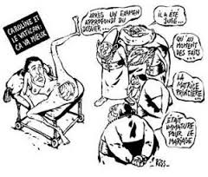](https://www.google.fr/imgres?imgurl=https://charliehebdo.fr/wp-content/uploads/2015/10/Untitled-21-300x256.jpg&imgrefurl=https://charliehebdo.fr/proces/&docid=Ealursax6EFQ9M&tbnid=QZkNAMhWeTL8_M:&vet=10ahUKEwiW0ISlou_VAhUFJFAKHS9TBwMQMwiCAShQMFA..i&w=300&h=256&client=firefox-b&bih=671&biw=1075&q=couverture%20anti-religieuse%20de%20charlie%20hebdo&ved=0ahUKEwiW0ISlou_VAhUFJFAKHS9TBwMQMwiCAShQMFA&iact=mrc&uact=8)

[](https://www.google.fr/imgres?imgurl=https://i.pinimg.com/736x/54/d8/62/54d86268a98266f8166bebb1490ddf5c--charlie-hebdo.jpg&imgrefurl=https://www.pinterest.com/UnesCharlie/charlie-hebdo-2017/&docid=Tqzgw8FiLSBDLM&tbnid=bYuz8iOvIsbeEM:&vet=10ahUKEwiW0ISlou_VAhUFJFAKHS9TBwMQMwiDAShRMFE..i&w=736&h=934&client=firefox-b&bih=671&biw=1075&q=couverture%20anti-religieuse%20de%20charlie%20hebdo&ved=0ahUKEwiW0ISlou_VAhUFJFAKHS9TBwMQMwiDAShRMFE&iact=mrc&uact=8)

[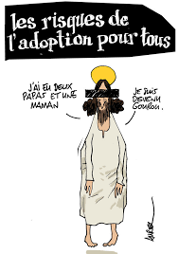](https://www.google.fr/imgres?imgurl=http://p4.storage.canalblog.com/40/13/177230/87545072_o.jpg&imgrefurl=http://stripsjournal.canalblog.com/tag/religion/p130-0.html&docid=rsN76PlaW6R21M&tbnid=57FPsWQgOtb39M:&vet=10ahUKEwiW0ISlou_VAhUFJFAKHS9TBwMQMwiEAShSMFI..i&w=650&h=929&client=firefox-b&bih=671&biw=1075&q=couverture%20anti-religieuse%20de%20charlie%20hebdo&ved=0ahUKEwiW0ISlou_VAhUFJFAKHS9TBwMQMwiEAShSMFI&iact=mrc&uact=8)

[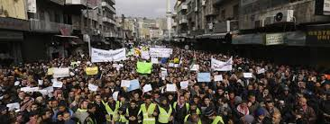](https://www.google.fr/imgres?imgurl=http://www.francetvinfo.fr/image/759r5jfoo-4e64/1200/450/9742697.jpg&imgrefurl=http://www.francetvinfo.fr/monde/violentes-manifestations-anti-charlie-hebdo-dans-plusieurs-pays-musulmans_1681839.html&docid=oUHJNf7gZ-nwfM&tbnid=4ZQKMo0ugMjnQM:&vet=10ahUKEwiW0ISlou_VAhUFJFAKHS9TBwMQMwiFAShTMFM..i&w=635&h=239&client=firefox-b&bih=671&biw=1075&q=couverture%20anti-religieuse%20de%20charlie%20hebdo&ved=0ahUKEwiW0ISlou_VAhUFJFAKHS9TBwMQMwiFAShTMFM&iact=mrc&uact=8)

[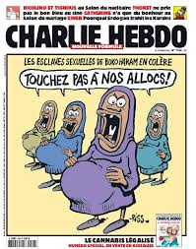](https://www.google.fr/imgres?imgurl=https://www.les-crises.fr/wp-content/uploads/2015/01/charlie-hebdo-48.jpg&imgrefurl=https://www.les-crises.fr/indecense-rendons-hommage-a-charlie/&docid=2U442jNNKZX6TM&tbnid=7Ru0oX4u5pTAAM:&vet=10ahUKEwiW0ISlou_VAhUFJFAKHS9TBwMQMwiGAShUMFQ..i&w=630&h=800&client=firefox-b&bih=671&biw=1075&q=couverture%20anti-religieuse%20de%20charlie%20hebdo&ved=0ahUKEwiW0ISlou_VAhUFJFAKHS9TBwMQMwiGAShUMFQ&iact=mrc&uact=8)

[](https://www.google.fr/imgres?imgurl=http://static.lexpress.fr/medias_10173/w_605,h_350,c_fill,g_north/v1423330526/un-homme-tient-une-couverture-de-charlie-hebdo-sur-la-laicite-lors-d-une-manifestation-le-11-janvier-2015-a-lyon_5208951.jpg&imgrefurl=http://www.lexpress.fr/actualite/societe/religion/laicite-an-1-apres-charlie_1751064.html&docid=HiFXcRohx5GV4M&tbnid=NGJ2vyhB6iOBvM:&vet=10ahUKEwiW0ISlou_VAhUFJFAKHS9TBwMQMwiHAShVMFU..i&w=605&h=350&client=firefox-b&bih=671&biw=1075&q=couverture%20anti-religieuse%20de%20charlie%20hebdo&ved=0ahUKEwiW0ISlou_VAhUFJFAKHS9TBwMQMwiHAShVMFU&iact=mrc&uact=8)

[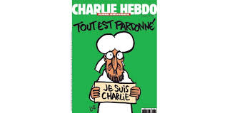](https://www.google.fr/imgres?imgurl=http://images.charentelibre.fr/2015/01/16/5645cdf17971bb340f4d3d59/default/1000/niger-45-eglises-brulees-dans-les-emeutes-anti-charlie-samedi.jpg&imgrefurl=http://www.charentelibre.fr/2015/01/16/charlie-hebdo-manifestations-hostiles-en-afrique-et-au-moyen-orient,1935508.php&docid=oR8lHHiTC9P2QM&tbnid=2M2QX1CoSCtREM:&vet=10ahUKEwiW0ISlou_VAhUFJFAKHS9TBwMQMwiJAShXMFc..i&w=1000&h=500&client=firefox-b&bih=671&biw=1075&q=couverture%20anti-religieuse%20de%20charlie%20hebdo&ved=0ahUKEwiW0ISlou_VAhUFJFAKHS9TBwMQMwiJAShXMFc&iact=mrc&uact=8)

[](https://www.google.fr/imgres?imgurl=https://www.marianne.net/sites/default/files/c5nzzjxxuaewqsg.jpg_large.jpeg&imgrefurl=https://www.marianne.net/politique/presidentielle-charlie-hebdo-interpelle-les-candidats-sur-la-laicite&docid=gPA5lKd0bwlwGM&tbnid=Q0Tbbm_hlA9ixM:&vet=10ahUKEwiW0ISlou_VAhUFJFAKHS9TBwMQMwiKAShYMFg..i&w=1181&h=1504&client=firefox-b&bih=671&biw=1075&q=couverture%20anti-religieuse%20de%20charlie%20hebdo&ved=0ahUKEwiW0ISlou_VAhUFJFAKHS9TBwMQMwiKAShYMFg&iact=mrc&uact=8)

[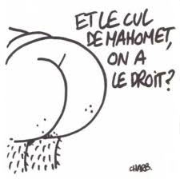](https://www.google.fr/imgres?imgurl=https://www.les-crises.fr/wp-content/uploads/2015/01/charlie-hebdo-03.jpg&imgrefurl=https://www.les-crises.fr/charlie-hebdo-pas-raciste-si-vous-le-dites-par-olivier-cyran/&docid=T3H0pxsOOpmbQM&tbnid=ISSPpMM_yC-kkM:&vet=10ahUKEwiW0ISlou_VAhUFJFAKHS9TBwMQMwiMAShaMFo..i&w=450&h=448&client=firefox-b&bih=671&biw=1075&q=couverture%20anti-religieuse%20de%20charlie%20hebdo&ved=0ahUKEwiW0ISlou_VAhUFJFAKHS9TBwMQMwiMAShaMFo&iact=mrc&uact=8)

[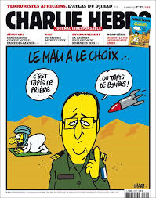](https://www.google.fr/imgres?imgurl=https://s-media-cache-ak0.pinimg.com/736x/e0/27/20/e02720585717b229dbfc6e017fdcaacc--je-suis-charlie-charlie-hebdo.jpg&imgrefurl=https://www.pinterest.co.uk/UnesCharlie/charlie-hebdo-2013/&docid=lNgDmr3HjkOlxM&tbnid=QhVgrmvlczo7ZM:&vet=10ahUKEwiW0ISlou_VAhUFJFAKHS9TBwMQMwiNAShbMFs..i&w=650&h=825&itg=1&client=firefox-b&bih=671&biw=1075&q=couverture%20anti-religieuse%20de%20charlie%20hebdo&ved=0ahUKEwiW0ISlou_VAhUFJFAKHS9TBwMQMwiNAShbMFs&iact=mrc&uact=8)

[](https://www.google.fr/imgres?imgurl=https://www.valeursactuelles.com/sites/default/files/logo-site-VA-480x220.jpg&imgrefurl=https://www.valeursactuelles.com/societe/islam-religion-de-paix-eternelle-cette-une-de-charlie-hebdo-qui-va-faire-parler-87766&docid=H4WA_CvdktMndM&tbnid=BFtDgGnliKGnnM:&vet=10ahUKEwiW0ISlou_VAhUFJFAKHS9TBwMQMwiUAShiMGI..i&w=480&h=220&client=firefox-b&bih=671&biw=1075&q=couverture%20anti-religieuse%20de%20charlie%20hebdo&ved=0ahUKEwiW0ISlou_VAhUFJFAKHS9TBwMQMwiUAShiMGI&iact=mrc&uact=8)

[](https://www.google.fr/imgres?imgurl=http://www.jewpop.com/wp-content/uploads/2011/11/charlie11.jpg&imgrefurl=http://jewpop.com/nous-sommes-tous-des-charlie-hebd/&docid=nj4jYUZKqJBShM&tbnid=O_t8lPD2r44ZFM:&vet=10ahUKEwj16Njeou_VAhUKKVAKHQSMCAk4ZBAzCAQoAjAC..i&w=333&h=400&client=firefox-b&bih=671&biw=1075&q=couverture%20anti-religieuse%20de%20charlie%20hebdo&ved=0ahUKEwj16Njeou_VAhUKKVAKHQSMCAk4ZBAzCAQoAjAC&iact=mrc&uact=8)

[](https://www.google.fr/imgres?imgurl=http://i.f1g.fr/media/figaro/805x453_crop/2016/01/05/XVM0e459008-b2fc-11e5-b8c6-70d04d1789d6.jpg&imgrefurl=http://www.lefigaro.fr/culture/2016/01/05/03004-20160105ARTFIG00188--la-une-de-charlie-hebdo-est-fidele-a-sa-tradition-anticlericale.php&docid=b_wp3uNI929TBM&tbnid=A4OVUrCogO2nlM:&vet=10ahUKEwj16Njeou_VAhUKKVAKHQSMCAk4ZBAzCAUoAzAD..i&w=471&h=453&client=firefox-b&bih=671&biw=1075&q=couverture%20anti-religieuse%20de%20charlie%20hebdo&ved=0ahUKEwj16Njeou_VAhUKKVAKHQSMCAk4ZBAzCAUoAzAD&iact=mrc&uact=8)

[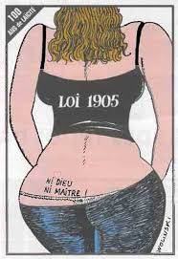](https://www.google.fr/imgres?imgurl=http://www.madinin-art.net/wp-content/uploads/2015/01/laicite_wolin.jpg&imgrefurl=http://www.madinin-art.net/sujet/charlie-hebdo/&docid=4l2dOUB5MaAPvM&tbnid=nC1F8UcNsfEuIM:&vet=10ahUKEwj16Njeou_VAhUKKVAKHQSMCAk4ZBAzCAYoBDAE..i&w=400&h=582&client=firefox-b&bih=671&biw=1075&q=couverture%20anti-religieuse%20de%20charlie%20hebdo&ved=0ahUKEwj16Njeou_VAhUKKVAKHQSMCAk4ZBAzCAYoBDAE&iact=mrc&uact=8)

[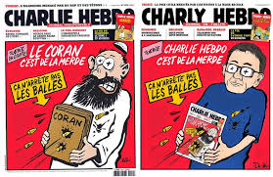](https://www.google.fr/imgres?imgurl=https://lh6.googleusercontent.com/-UswtaiwbOXs/VLJeJeB2CXI/AAAAAAAAA4Y/Vj30n-WdIWA/w800-h800/Coran-Charlie-Dedko.jpg&imgrefurl=https://plus.google.com/+TariqRamadanHD/posts/PYfM26w9bDF&docid=rtTpY4jO9Jc67M&tbnid=0xHeQHWbxlm_kM:&vet=10ahUKEwj16Njeou_VAhUKKVAKHQSMCAk4ZBAzCAgoBjAG..i&w=800&h=520&client=firefox-b&bih=671&biw=1075&q=couverture%20anti-religieuse%20de%20charlie%20hebdo&ved=0ahUKEwj16Njeou_VAhUKKVAKHQSMCAk4ZBAzCAgoBjAG&iact=mrc&uact=8)

[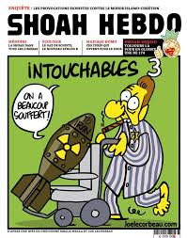](https://www.google.fr/imgres?imgurl=https://hichamhamza.files.wordpress.com/2012/09/joecorbeau.jpg&imgrefurl=https://hichamhamza.wordpress.com/2012/09/20/lexpress-charlie-hebdo-censure/&docid=0dl0Mp1qPNYFVM&tbnid=D6hOxU3P4qLvAM:&vet=10ahUKEwj16Njeou_VAhUKKVAKHQSMCAk4ZBAzCAkoBzAH..i&w=756&h=960&client=firefox-b&bih=671&biw=1075&q=couverture%20anti-religieuse%20de%20charlie%20hebdo&ved=0ahUKEwj16Njeou_VAhUKKVAKHQSMCAk4ZBAzCAkoBzAH&iact=mrc&uact=8)

[](https://www.google.fr/imgres?imgurl=https://lebloglaquestion.files.wordpress.com/2009/10/cathophobie-de-charlie-hebdo.jpg?w=214&h=300&imgrefurl=https://lebloglaquestion.wordpress.com/2009/10/22/que-crevent-les-blasphemateurs-antichretiens/&docid=VaI5UN03hxs33M&tbnid=h5Kt_dREGp3ltM:&vet=10ahUKEwj16Njeou_VAhUKKVAKHQSMCAk4ZBAzCAooCDAI..i&w=214&h=280&client=firefox-b&bih=671&biw=1075&q=couverture%20anti-religieuse%20de%20charlie%20hebdo&ved=0ahUKEwj16Njeou_VAhUKKVAKHQSMCAk4ZBAzCAooCDAI&iact=mrc&uact=8)

[[](https://www.google.fr/imgres?imgurl=http://www.lepoint.fr/images/2017/08/23/9817521lpw-9817612-article-jpg_4505738_660x281.jpg&imgrefurl=http://www.lepoint.fr/medias/attentats-de-catalogne-la-une-de-charlie-hebdo-divise-23-08-2017-2151647_260.php&docid=SZLTHcDkaqgxwM&tbnid=1jOAZwHGLlR4xM:&vet=10ahUKEwj16Njeou_VAhUKKVAKHQSMCAk4ZBAzCAsoCTAJ..i&w=660&h=281&client=firefox-b&bih=671&biw=1075&q=couverture%20anti-religieuse%20de%20charlie%20hebdo&ved=0ahUKEwj16Njeou_VAhUKKVAKHQSMCAk4ZBAzCAsoCTAJ&iact=mrc&uact=8)](https://www.google.fr/imgres?imgurl=http%3A%2F%2Fwww.lepoint.fr%2Fimages%2F2017%2F08%2F23%2F9817521lpw-9817612-article-jpg_4505738_660x281.jpg&imgrefurl=http%3A%2F%2Fwww.lepoint.fr%2Fmedias%2Fattentats-de-catalogne-la-une-de-charlie-hebdo-divise-23-08-2017-2151647_260.php&docid=SZLTHcDkaqgxwM&tbnid=1jOAZwHGLlR4xM%3A&vet=10ahUKEwj16Njeou_VAhUKKVAKHQSMCAk4ZBAzCAsoCTAJ..i&w=660&h=281&client=firefox-b&bih=671&biw=1075&q=couverture%20anti-religieuse%20de%20charlie%20hebdo&ved=0ahUKEwj16Njeou_VAhUKKVAKHQSMCAk4ZBAzCAsoCTAJ&iact=mrc&uact=8)

[il y a 21 heures](https://www.google.fr/imgres?imgurl=http%3A%2F%2Fwww.lepoint.fr%2Fimages%2F2017%2F08%2F23%2F9817521lpw-9817612-article-jpg_4505738_660x281.jpg&imgrefurl=http%3A%2F%2Fwww.lepoint.fr%2Fmedias%2Fattentats-de-catalogne-la-une-de-charlie-hebdo-divise-23-08-2017-2151647_260.php&docid=SZLTHcDkaqgxwM&tbnid=1jOAZwHGLlR4xM%3A&vet=10ahUKEwj16Njeou_VAhUKKVAKHQSMCAk4ZBAzCAsoCTAJ..i&w=660&h=281&client=firefox-b&bih=671&biw=1075&q=couverture%20anti-religieuse%20de%20charlie%20hebdo&ved=0ahUKEwj16Njeou_VAhUKKVAKHQSMCAk4ZBAzCAsoCTAJ&iact=mrc&uact=8)

[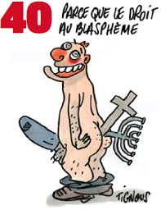](https://www.google.fr/imgres?imgurl=http://p9.storage.canalblog.com/92/75/177230/82702786_o.png&imgrefurl=http://stripsjournal.canalblog.com/tag/religion/p130-0.html&docid=rsN76PlaW6R21M&tbnid=nqcOhw-_KvW0aM:&vet=10ahUKEwj16Njeou_VAhUKKVAKHQSMCAk4ZBAzCA4oCzAL..i&w=288&h=374&client=firefox-b&bih=671&biw=1075&q=couverture%20anti-religieuse%20de%20charlie%20hebdo&ved=0ahUKEwj16Njeou_VAhUKKVAKHQSMCAk4ZBAzCA4oCzAL&iact=mrc&uact=8)

[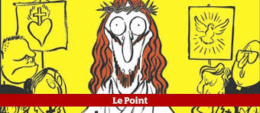](https://www.google.fr/imgres?imgurl=http://www.lepoint.fr/images/2012/09/20/charlie-hebdo-682792-jpg_468939.JPG&imgrefurl=http://www.lepoint.fr/societe/charlie-hebdo-s-en-prend-il-a-toutes-les-religions-20-09-2012-1508355_23.php&docid=lQr_pyHcuBvyaM&tbnid=WrVwQpSLZj3ZQM:&vet=10ahUKEwj16Njeou_VAhUKKVAKHQSMCAk4ZBAzCA8oDDAM..i&w=652&h=284&client=firefox-b&bih=671&biw=1075&q=couverture%20anti-religieuse%20de%20charlie%20hebdo&ved=0ahUKEwj16Njeou_VAhUKKVAKHQSMCAk4ZBAzCA8oDDAM&iact=mrc&uact=8)

[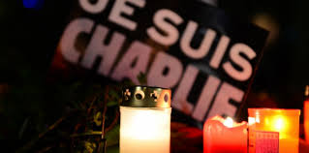](https://www.google.fr/imgres?imgurl=http://referentiel.nouvelobs.com/file/13589611-charlie-hebdo-les-representants-religieux-condamnent-l-attentat.jpg&imgrefurl=http://tempsreel.nouvelobs.com/charlie-hebdo/20150107.OBS9494/charlie-hebdo-les-representants-religieux-condamnent-l-attentat.html&docid=D8p2_vSmoV0tzM&tbnid=ZSCGU3pByIpQuM:&vet=10ahUKEwj16Njeou_VAhUKKVAKHQSMCAk4ZBAzCBEoDjAO..i&w=833&h=413&itg=1&client=firefox-b&bih=671&biw=1075&q=couverture%20anti-religieuse%20de%20charlie%20hebdo&ved=0ahUKEwj16Njeou_VAhUKKVAKHQSMCAk4ZBAzCBEoDjAO&iact=mrc&uact=8)

[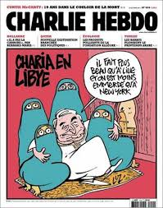](https://www.google.fr/imgres?imgurl=https://eplume.files.wordpress.com/2011/11/dsk-charli-hebdo-val-charb.jpg&imgrefurl=https://eplume.wordpress.com/2011/11/03/charlie-hebdo-au-bucher-la-caricature-d%E2%80%99un-%C2%AB-attentat-%C2%BB-islamiste/&docid=VjFwyOX-n_dd8M&tbnid=laB6-rVzqMHz6M:&vet=10ahUKEwj16Njeou_VAhUKKVAKHQSMCAk4ZBAzCBIoDzAP..i&w=471&h=600&client=firefox-b&bih=671&biw=1075&q=couverture%20anti-religieuse%20de%20charlie%20hebdo&ved=0ahUKEwj16Njeou_VAhUKKVAKHQSMCAk4ZBAzCBIoDzAP&iact=mrc&uact=8)

[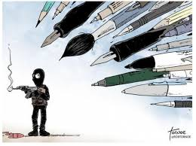](https://www.google.fr/imgres?imgurl=https://www.challenges.fr/assets/img/2015/01/09/images_list-r4x3w1000-5791f13fba429-090115-challenges-rob-tornoe-philadelphia-inquirer.jpg&imgrefurl=https://www.challenges.fr/media/le-prix-du-dernier-numero-de-charlie-hebdo-s-envole-sur-ebay_33748&docid=_tlir6gPOfoMgM&tbnid=-xqCc360uIC-XM:&vet=10ahUKEwj16Njeou_VAhUKKVAKHQSMCAk4ZBAzCBQoETAR..i&w=1000&h=748&client=firefox-b&bih=671&biw=1075&q=couverture%20anti-religieuse%20de%20charlie%20hebdo&ved=0ahUKEwj16Njeou_VAhUKKVAKHQSMCAk4ZBAzCBQoETAR&iact=mrc&uact=8)

[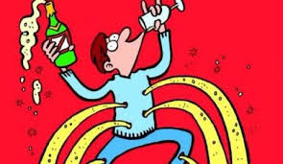](https://www.google.fr/imgres?imgurl=http://www.konbini.com/wp-content/blogs.dir/3/files/2015/11/charlie-480x279.jpg&imgrefurl=http://www.konbini.com/fr/tendances-2/nouvelle-une-charlie-hebdo-attentats/&docid=gSy5VLRXeJr1tM&tbnid=AHX4xPefFkAYbM:&vet=10ahUKEwj16Njeou_VAhUKKVAKHQSMCAk4ZBAzCBYoEzAT..i&w=480&h=279&client=firefox-b&bih=671&biw=1075&q=couverture%20anti-religieuse%20de%20charlie%20hebdo&ved=0ahUKEwj16Njeou_VAhUKKVAKHQSMCAk4ZBAzCBYoEzAT&iact=mrc&uact=8)

[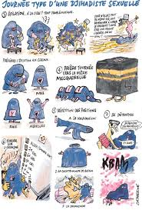](https://www.google.fr/imgres?imgurl=https://www.les-crises.fr/wp-content/uploads/2015/01/charlie-hebdo-02.jpg&imgrefurl=https://www.les-crises.fr/charlie-hebdo-pas-raciste-si-vous-le-dites-par-olivier-cyran/&docid=T3H0pxsOOpmbQM&tbnid=MnS0xlsoiOpUcM:&vet=10ahUKEwj16Njeou_VAhUKKVAKHQSMCAk4ZBAzCBcoFDAU..i&w=392&h=578&client=firefox-b&bih=671&biw=1075&q=couverture%20anti-religieuse%20de%20charlie%20hebdo&ved=0ahUKEwj16Njeou_VAhUKKVAKHQSMCAk4ZBAzCBcoFDAU&iact=mrc&uact=8)

[](https://www.google.fr/imgres?imgurl=https://www.les-crises.fr/wp-content/uploads/2015/01/charlie-hebdo-04.jpg&imgrefurl=https://www.les-crises.fr/charlie-hebdo-pas-raciste-si-vous-le-dites-par-olivier-cyran/&docid=T3H0pxsOOpmbQM&tbnid=lZcXKOacuzzeHM:&vet=10ahUKEwj16Njeou_VAhUKKVAKHQSMCAk4ZBAzCBkoFjAW..i&w=652&h=284&client=firefox-b&bih=671&biw=1075&q=couverture%20anti-religieuse%20de%20charlie%20hebdo&ved=0ahUKEwj16Njeou_VAhUKKVAKHQSMCAk4ZBAzCBkoFjAW&iact=mrc&uact=8)

[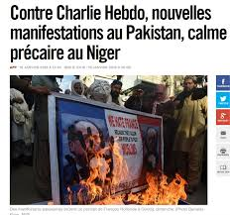](https://www.google.fr/imgres?imgurl=https://www.les-crises.fr/wp-content/uploads/2015/01/ch-pakistan-2.jpg&imgrefurl=https://www.les-crises.fr/troubles-dessinateur-reagit/&docid=4SIk6Ug_2L5USM&tbnid=R-dWHai3YcLZjM:&vet=10ahUKEwj16Njeou_VAhUKKVAKHQSMCAk4ZBAzCBooFzAX..i&w=872&h=815&itg=1&client=firefox-b&bih=671&biw=1075&q=couverture%20anti-religieuse%20de%20charlie%20hebdo&ved=0ahUKEwj16Njeou_VAhUKKVAKHQSMCAk4ZBAzCBooFzAX&iact=mrc&uact=8)

[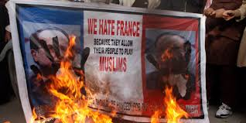](https://www.google.fr/imgres?imgurl=http://o.aolcdn.com/images/dims?thumbnail=2000,1000&image_uri=http://i.huffpost.com/gen/2506064/images/n-CHARLIE-HEBDO-MANIFESTATIONS-628x314.jpg&client=cbc79c14efcebee57402&signature=657e7d68c9e3104e593cac10ec9f0d35bd0167f4&imgrefurl=http://www.huffingtonpost.fr/2015/01/18/charlie-hebdo-manifestations-pakistan-mahomet-drapeaux-francais-brules_n_6496952.html&docid=2LHri9fhDIjpUM&tbnid=H5B57y4WzcaErM:&vet=10ahUKEwj16Njeou_VAhUKKVAKHQSMCAk4ZBAzCB0oGjAa..i&w=2000&h=1000&client=firefox-b&bih=671&biw=1075&q=couverture%20anti-religieuse%20de%20charlie%20hebdo&ved=0ahUKEwj16Njeou_VAhUKKVAKHQSMCAk4ZBAzCB0oGjAa&iact=mrc&uact=8)

[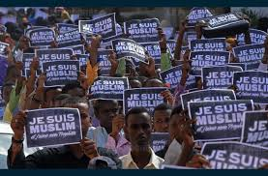](https://www.google.fr/imgres?imgurl=http://s-www.leprogres.fr/images/0CFEE6E8-E7DC-4CD4-92F5-01306501D2BE/LPR_v1_02/manifestation-anti-caricature-en-somalie-je-suis-musulman-et-j-aime-mon-prophete-photo-afp-1479278308.jpg&imgrefurl=http://www.leprogres.fr/politique/2015/01/19/cette-caricature-qui-agace&docid=kfGmz2wYkcXL4M&tbnid=zEgXG7cwV-Q6hM:&vet=10ahUKEwj16Njeou_VAhUKKVAKHQSMCAk4ZBAzCB4oGzAb..i&w=940&h=620&client=firefox-b&bih=671&biw=1075&q=couverture%20anti-religieuse%20de%20charlie%20hebdo&ved=0ahUKEwj16Njeou_VAhUKKVAKHQSMCAk4ZBAzCB4oGzAb&iact=mrc&uact=8)

[[](https://www.google.fr/imgres?imgurl=http://lemonde.co.il/wp-content/uploads/2017/08/photos.lci_.frcharlie-hebdo-une-58031e-9b4ebaa79b3f9ac939d4dc40615103d9d3c31e93-696x1062.jpeg&imgrefurl=http://lemonde.co.il/2017/08/23/la-une-de-charlie-hebdo-consacre-aux-attentats-en-catalogne-accuse-d039amalgame-entre-islam-et-terrorisme-lci/&docid=QPFbHu4kpQ5RxM&tbnid=0nZZrTEQv94EFM:&vet=10ahUKEwj16Njeou_VAhUKKVAKHQSMCAk4ZBAzCB8oHDAc..i&w=696&h=1062&client=firefox-b&bih=671&biw=1075&q=couverture%20anti-religieuse%20de%20charlie%20hebdo&ved=0ahUKEwj16Njeou_VAhUKKVAKHQSMCAk4ZBAzCB8oHDAc&iact=mrc&uact=8)](https://www.google.fr/imgres?imgurl=http%3A%2F%2Flemonde.co.il%2Fwp-content%2Fuploads%2F2017%2F08%2Fphotos.lci_.frcharlie-hebdo-une-58031e-9b4ebaa79b3f9ac939d4dc40615103d9d3c31e93-696x1062.jpeg&imgrefurl=http%3A%2F%2Flemonde.co.il%2F2017%2F08%2F23%2Fla-une-de-charlie-hebdo-consacre-aux-attentats-en-catalogne-accuse-d039amalgame-entre-islam-et-terrorisme-lci%2F&docid=QPFbHu4kpQ5RxM&tbnid=0nZZrTEQv94EFM%3A&vet=10ahUKEwj16Njeou_VAhUKKVAKHQSMCAk4ZBAzCB8oHDAc..i&w=696&h=1062&client=firefox-b&bih=671&biw=1075&q=couverture%20anti-religieuse%20de%20charlie%20hebdo&ved=0ahUKEwj16Njeou_VAhUKKVAKHQSMCAk4ZBAzCB8oHDAc&iact=mrc&uact=8)

[il y a 1 jour](https://www.google.fr/imgres?imgurl=http%3A%2F%2Flemonde.co.il%2Fwp-content%2Fuploads%2F2017%2F08%2Fphotos.lci_.frcharlie-hebdo-une-58031e-9b4ebaa79b3f9ac939d4dc40615103d9d3c31e93-696x1062.jpeg&imgrefurl=http%3A%2F%2Flemonde.co.il%2F2017%2F08%2F23%2Fla-une-de-charlie-hebdo-consacre-aux-attentats-en-catalogne-accuse-d039amalgame-entre-islam-et-terrorisme-lci%2F&docid=QPFbHu4kpQ5RxM&tbnid=0nZZrTEQv94EFM%3A&vet=10ahUKEwj16Njeou_VAhUKKVAKHQSMCAk4ZBAzCB8oHDAc..i&w=696&h=1062&client=firefox-b&bih=671&biw=1075&q=couverture%20anti-religieuse%20de%20charlie%20hebdo&ved=0ahUKEwj16Njeou_VAhUKKVAKHQSMCAk4ZBAzCB8oHDAc&iact=mrc&uact=8)

[](https://www.google.fr/imgres?imgurl=https://o.aolcdn.com/images/dims3/GLOB/legacy_thumbnail/1200x630/format/jpg/quality/85/http://i.huffpost.com/gen/2483928/images/n-CHARLIE-HEBDO-COUVERTURE-628x314.jpg&imgrefurl=http://www.huffingtonpost.fr/2015/01/13/couverture-charlie-hebdo-egypte-mahomet-islam-cfcm-uoif_n_6462050.html&docid=BUrBxpHNixffVM&tbnid=kiwUCt3yuvrgLM:&vet=10ahUKEwj16Njeou_VAhUKKVAKHQSMCAk4ZBAzCCEoHTAd..i&w=1200&h=630&client=firefox-b&bih=671&biw=1075&q=couverture%20anti-religieuse%20de%20charlie%20hebdo&ved=0ahUKEwj16Njeou_VAhUKKVAKHQSMCAk4ZBAzCCEoHTAd&iact=mrc&uact=8)

[](https://www.google.fr/imgres?imgurl=https://static.mediapart.fr/etmagine/default/files/media_205822/charb-0701.jpg?width=249&height=250&width_format=pixel&height_format=pixel&imgrefurl=https://www.mediapart.fr/journal/france/dossier/dossier-les-attentats-de-janvier-2015-paris&docid=_1rhxaeqJjKeBM&tbnid=aLVz4vHLlqh9NM:&vet=10ahUKEwj16Njeou_VAhUKKVAKHQSMCAk4ZBAzCCQoIDAg..i&w=661&h=664&client=firefox-b&bih=671&biw=1075&q=couverture%20anti-religieuse%20de%20charlie%20hebdo&ved=0ahUKEwj16Njeou_VAhUKKVAKHQSMCAk4ZBAzCCQoIDAg&iact=mrc&uact=8)

[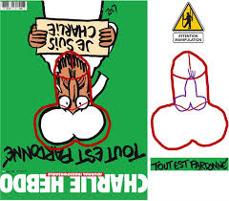](https://www.google.fr/imgres?imgurl=http://www.les-crises.fr/wp-content/uploads/2015/01/charlie-hebdo-91.jpg&imgrefurl=http://numidia-liberum.blogspot.com/2015/01/charlie-hebdo-tue-niger-5-morts-45.html&docid=lguDVq_TVivtpM&tbnid=96xG-TUtMhW3bM:&vet=10ahUKEwj16Njeou_VAhUKKVAKHQSMCAk4ZBAzCCUoITAh..i&w=725&h=635&client=firefox-b&bih=671&biw=1075&q=couverture%20anti-religieuse%20de%20charlie%20hebdo&ved=0ahUKEwj16Njeou_VAhUKKVAKHQSMCAk4ZBAzCCUoITAh&iact=mrc&uact=8)

[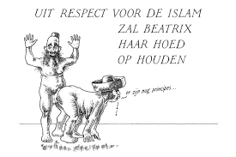](https://www.google.fr/imgres?imgurl=https://www.les-crises.fr/wp-content/uploads/2015/01/charlie-hebdo-23.jpg&imgrefurl=https://www.les-crises.fr/charlie-hebdo-pas-raciste-si-vous-le-dites-par-olivier-cyran/&docid=T3H0pxsOOpmbQM&tbnid=cuKuWTvNH0P5NM:&vet=10ahUKEwj16Njeou_VAhUKKVAKHQSMCAk4ZBAzCCYoIjAi..i&w=570&h=380&client=firefox-b&bih=671&biw=1075&q=couverture%20anti-religieuse%20de%20charlie%20hebdo&ved=0ahUKEwj16Njeou_VAhUKKVAKHQSMCAk4ZBAzCCYoIjAi&iact=mrc&uact=8)

[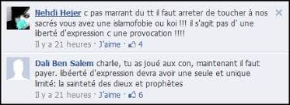](https://www.google.fr/imgres?imgurl=http://rezonances.blog.lemonde.fr/files/2011/11/charlieanti1.jpg&imgrefurl=http://rezonances.blog.lemonde.fr/2011/11/03/incendie-a-charlie-hebdo-libertes-et-vivre-ensemble-en-debat/&docid=t_Sou-hTZqyQsM&tbnid=5bYUjdnrN-EeMM:&vet=10ahUKEwj16Njeou_VAhUKKVAKHQSMCAk4ZBAzCCcoIzAj..i&w=440&h=160&itg=1&client=firefox-b&bih=671&biw=1075&q=couverture%20anti-religieuse%20de%20charlie%20hebdo&ved=0ahUKEwj16Njeou_VAhUKKVAKHQSMCAk4ZBAzCCcoIzAj&iact=mrc&uact=8)

[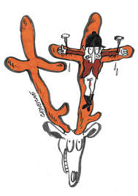](https://www.google.fr/imgres?imgurl=http://p9.storage.canalblog.com/92/38/177230/60174683.jpg&imgrefurl=http://stripsjournal.canalblog.com/archives/2010/12/p20-0.html&docid=eKuRMuzngQSFeM&tbnid=kZqzsyti6NngkM:&vet=10ahUKEwj16Njeou_VAhUKKVAKHQSMCAk4ZBAzCCooJjAm..i&w=300&h=423&client=firefox-b&bih=671&biw=1075&q=couverture%20anti-religieuse%20de%20charlie%20hebdo&ved=0ahUKEwj16Njeou_VAhUKKVAKHQSMCAk4ZBAzCCooJjAm&iact=mrc&uact=8)

[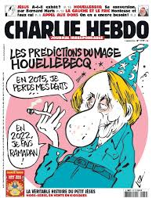](https://www.google.fr/imgres?imgurl=http://p2.storage.canalblog.com/24/72/177230/101392446_o.jpg&imgrefurl=http://stripsjournal.canalblog.com/tag/Les%20Unes%20de%20Charlie%20Hebdo/p80-0.html&docid=ncFirTAB4IAu7M&tbnid=EUp4kue-vVcyMM:&vet=10ahUKEwj16Njeou_VAhUKKVAKHQSMCAk4ZBAzCCsoJzAn..i&w=650&h=825&client=firefox-b&bih=671&biw=1075&q=couverture%20anti-religieuse%20de%20charlie%20hebdo&ved=0ahUKEwj16Njeou_VAhUKKVAKHQSMCAk4ZBAzCCsoJzAn&iact=mrc&uact=8)

[](https://www.google.fr/imgres?imgurl=http://media.medias-presse.info/wp-content/uploads/2015/01/charlie-hebdo-cest-cela-202x300.jpg&imgrefurl=http://www.medias-presse.info/le-blaspheme-et-le-sacrilege-napportent-jamais-la-paix/22327/&docid=AhifwPdZEb96PM&tbnid=ceyDPZYEqjLP5M:&vet=10ahUKEwj16Njeou_VAhUKKVAKHQSMCAk4ZBAzCCwoKDAo..i&w=202&h=300&client=firefox-b&bih=671&biw=1075&q=couverture%20anti-religieuse%20de%20charlie%20hebdo&ved=0ahUKEwj16Njeou_VAhUKKVAKHQSMCAk4ZBAzCCwoKDAo&iact=mrc&uact=8)

[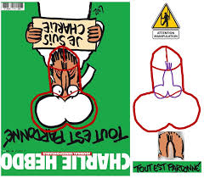](https://www.google.fr/imgres?imgurl=https://www.les-crises.fr/wp-content/uploads/2015/01/charlie-hebdo-92.jpg&imgrefurl=https://www.les-crises.fr/couverture-mahomet/&docid=Tox-cupsRM-fXM&tbnid=tPwuzIMlCUERVM:&vet=10ahUKEwj16Njeou_VAhUKKVAKHQSMCAk4ZBAzCC0oKTAp..i&w=791&h=691&client=firefox-b&bih=671&biw=1075&q=couverture%20anti-religieuse%20de%20charlie%20hebdo&ved=0ahUKEwj16Njeou_VAhUKKVAKHQSMCAk4ZBAzCC0oKTAp&iact=mrc&uact=8)

[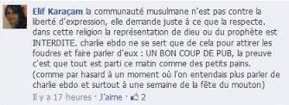](https://www.google.fr/imgres?imgurl=http://rezonances.blog.lemonde.fr/files/2011/11/charlieanti21.jpg&imgrefurl=http://rezonances.blog.lemonde.fr/2011/11/03/incendie-a-charlie-hebdo-libertes-et-vivre-ensemble-en-debat/&docid=t_Sou-hTZqyQsM&tbnid=DgQJTI7ZaGLg8M:&vet=10ahUKEwj16Njeou_VAhUKKVAKHQSMCAk4ZBAzCC4oKjAq..i&w=418&h=153&itg=1&client=firefox-b&bih=671&biw=1075&q=couverture%20anti-religieuse%20de%20charlie%20hebdo&ved=0ahUKEwj16Njeou_VAhUKKVAKHQSMCAk4ZBAzCC4oKjAq&iact=mrc&uact=8)

[](https://www.google.fr/imgres?imgurl=https://upload.wikimedia.org/wikipedia/commons/thumb/0/0b/Conf%C3%A9rence_presse_Charlie_Hebdo_janvier_2015.jpg/260px-Conf%C3%A9rence_presse_Charlie_Hebdo_janvier_2015.jpg&imgrefurl=https://fr.wikipedia.org/wiki/Charlie_Hebdo&docid=PsSrF0SpI2PzGM&tbnid=CwrKWMw1UAxcaM:&vet=10ahUKEwj16Njeou_VAhUKKVAKHQSMCAk4ZBAzCC8oKzAr..i&w=260&h=195&client=firefox-b&bih=671&biw=1075&q=couverture%20anti-religieuse%20de%20charlie%20hebdo&ved=0ahUKEwj16Njeou_VAhUKKVAKHQSMCAk4ZBAzCC8oKzAr&iact=mrc&uact=8)

[](https://www.google.fr/imgres?imgurl=http://cdn.mediaeducation.fr/_files/img/front/content/se-documenter/articles/article_content_31-4.jpg&imgrefurl=https://www.mediaeducation.fr/fr/Se-documenter/lire/Charlie-Hebdo/31.htm&docid=4sVxj2zWe5iFBM&tbnid=Pkn4q6RakwTwvM:&vet=10ahUKEwj16Njeou_VAhUKKVAKHQSMCAk4ZBAzCDEoLTAt..i&w=465&h=290&client=firefox-b&bih=671&biw=1075&q=couverture%20anti-religieuse%20de%20charlie%20hebdo&ved=0ahUKEwj16Njeou_VAhUKKVAKHQSMCAk4ZBAzCDEoLTAt&iact=mrc&uact=8)

[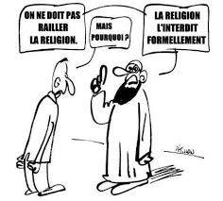](https://www.google.fr/imgres?imgurl=http://p0.storage.canalblog.com/09/21/1046701/79819033_o.jpg&imgrefurl=http://pastafarien.canalblog.com/archives/2012/10/04/25295363.html&docid=31u3icVFGS61uM&tbnid=mM4wUznUWffJvM:&vet=10ahUKEwj16Njeou_VAhUKKVAKHQSMCAk4ZBAzCDMoLzAv..i&w=454&h=410&client=firefox-b&bih=671&biw=1075&q=couverture%20anti-religieuse%20de%20charlie%20hebdo&ved=0ahUKEwj16Njeou_VAhUKKVAKHQSMCAk4ZBAzCDMoLzAv&iact=mrc&uact=8)

[](https://www.google.fr/imgres?imgurl=http://p2.storage.canalblog.com/23/05/177230/83731573_o.jpg&imgrefurl=http://stripsjournal.canalblog.com/tag/Les%20Unes%20de%20Charlie%20Hebdo/p180-0.html&docid=2N9sJs7iIMdb3M&tbnid=ajG1mFZtg4MLRM:&vet=10ahUKEwj16Njeou_VAhUKKVAKHQSMCAk4ZBAzCDQoMDAw..i&w=650&h=824&client=firefox-b&bih=671&biw=1075&q=couverture%20anti-religieuse%20de%20charlie%20hebdo&ved=0ahUKEwj16Njeou_VAhUKKVAKHQSMCAk4ZBAzCDQoMDAw&iact=mrc&uact=8)

[](https://www.google.fr/imgres?imgurl=https://www.marianne.net/sites/default/files/styles/mrn_article_large/public/c5nzzjxxuaewqsg.jpg_large.jpeg?itok=xWUDeMmO&imgrefurl=https://www.marianne.net/politique/presidentielle-charlie-hebdo-interpelle-les-candidats-sur-la-laicite&docid=gPA5lKd0bwlwGM&tbnid=boitK5ikeIQigM:&vet=10ahUKEwj16Njeou_VAhUKKVAKHQSMCAk4ZBAzCDUoMTAx..i&w=790&h=445&client=firefox-b&bih=671&biw=1075&q=couverture%20anti-religieuse%20de%20charlie%20hebdo&ved=0ahUKEwj16Njeou_VAhUKKVAKHQSMCAk4ZBAzCDUoMTAx&iact=mrc&uact=8)

[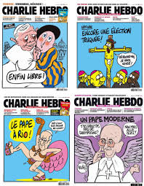](https://www.google.fr/imgres?imgurl=http://www.20min.ch/diashow/117318/117318-JwSoONPKnc5YecVDDVw4pg.jpg&imgrefurl=http://www.20min.ch/ro/news/dossier/charlie/story/27765809&docid=D2_HZWGcdtzeSM&tbnid=pZMtSLaBQxJ8SM:&vet=10ahUKEwj16Njeou_VAhUKKVAKHQSMCAk4ZBAzCDgoNDA0..i&w=466&h=600&client=firefox-b&bih=671&biw=1075&q=couverture%20anti-religieuse%20de%20charlie%20hebdo&ved=0ahUKEwj16Njeou_VAhUKKVAKHQSMCAk4ZBAzCDgoNDA0&iact=mrc&uact=8)

[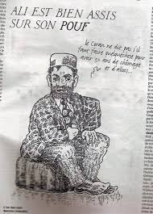](https://www.google.fr/imgres?imgurl=https://www.les-crises.fr/wp-content/uploads/2015/01/charlie-hebdo-22.jpg&imgrefurl=https://www.les-crises.fr/charlie-hebdo-pas-raciste-si-vous-le-dites-par-olivier-cyran/&docid=T3H0pxsOOpmbQM&tbnid=GWsBqLqvpL4H0M:&vet=10ahUKEwj16Njeou_VAhUKKVAKHQSMCAk4ZBAzCDwoODA4..i&w=350&h=487&itg=1&client=firefox-b&bih=671&biw=1075&q=couverture%20anti-religieuse%20de%20charlie%20hebdo&ved=0ahUKEwj16Njeou_VAhUKKVAKHQSMCAk4ZBAzCDwoODA4&iact=mrc&uact=8)

[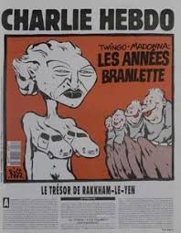](https://www.google.fr/imgres?imgurl=https://s-media-cache-ak0.pinimg.com/236x/45/b9/9e/45b99eaffdd863ef77618d6d9c1ff28d--charlie-hebdo.jpg&imgrefurl=https://www.pinterest.com/pin/529454499919833191/&docid=IFNnOlT5rye9tM&tbnid=QjNDzr0FRg_79M:&vet=10ahUKEwj16Njeou_VAhUKKVAKHQSMCAk4ZBAzCD0oOTA5..i&w=236&h=304&itg=1&client=firefox-b&bih=671&biw=1075&q=couverture%20anti-religieuse%20de%20charlie%20hebdo&ved=0ahUKEwj16Njeou_VAhUKKVAKHQSMCAk4ZBAzCD0oOTA5&iact=mrc&uact=8)

[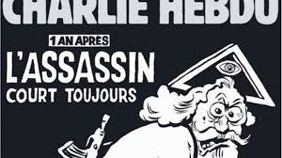](https://www.google.fr/imgres?imgurl=http://static.lexpress.fr/medias_10726/w_521,h_391,c_crop,x_0,y_0/w_640,h_358,c_fill,g_center/v1451908994/charlie-hebdo-un-an-apres_5492124.jpeg&imgrefurl=http://www.lexpress.fr/actualite/societe/attentat-de-charlie-hebdo-ils-se-souviennent-du-7-janvier_1696688.html&docid=CQkCs5NJIwy6_M&tbnid=oDe9txARGtgWSM:&vet=10ahUKEwj16Njeou_VAhUKKVAKHQSMCAk4ZBAzCD4oOjA6..i&w=640&h=358&client=firefox-b&bih=671&biw=1075&q=couverture%20anti-religieuse%20de%20charlie%20hebdo&ved=0ahUKEwj16Njeou_VAhUKKVAKHQSMCAk4ZBAzCD4oOjA6&iact=mrc&uact=8)

[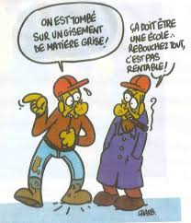](https://www.google.fr/imgres?imgurl=http://www.politproductions.com/sites/default/files/img-hommage_a_charlie_hebdo-dessin_de_charb_paru_dans_une_revue_de_la_fsu_en_1999-reed_us_no_749-17_01_2015.jpg&imgrefurl=http://www.politproductions.com/node/3283&docid=Y7V8mmjtTnY4tM&tbnid=aUUl8gJtsTj-4M:&vet=10ahUKEwj16Njeou_VAhUKKVAKHQSMCAk4ZBAzCD8oOzA7..i&w=2670&h=3108&client=firefox-b&bih=671&biw=1075&q=couverture%20anti-religieuse%20de%20charlie%20hebdo&ved=0ahUKEwj16Njeou_VAhUKKVAKHQSMCAk4ZBAzCD8oOzA7&iact=mrc&uact=8)

[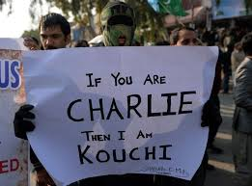](https://www.google.fr/imgres?imgurl=http://md1.libe.com/photo/708351-000_ts-del6387604.jpg?modified_at=1421485406&width=750&imgrefurl=http://www.liberation.fr/planete/2015/01/17/contre-la-une-de-charlie-hebdo-des-manifestations-parfois-violentes-dans-le-monde-musulman_1182645&docid=tfko8leurpFlNM&tbnid=aJTT186UfYgJXM:&vet=10ahUKEwj16Njeou_VAhUKKVAKHQSMCAk4ZBAzCEAoPDA8..i&w=750&h=556&client=firefox-b&bih=671&biw=1075&q=couverture%20anti-religieuse%20de%20charlie%20hebdo&ved=0ahUKEwj16Njeou_VAhUKKVAKHQSMCAk4ZBAzCEAoPDA8&iact=mrc&uact=8)

[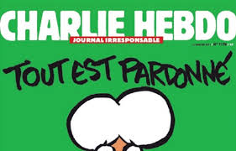](https://www.google.fr/imgres?imgurl=https://img.20mn.fr/z6D58abjSN-PVsptAy0xXA/1200x768_extrait-charlie-hebdo-mercredi-13-janvier&imgrefurl=http://www.20minutes.fr/societe/1515875-20150113-charlie-hebdo-caricature-charlie-dit-monde-islam-cautionne-terrorisme&docid=fG8miUR1RYZaFM&tbnid=r7CHqivNyznJ7M:&vet=10ahUKEwj16Njeou_VAhUKKVAKHQSMCAk4ZBAzCEEoPTA9..i&w=1200&h=768&client=firefox-b&bih=671&biw=1075&q=couverture%20anti-religieuse%20de%20charlie%20hebdo&ved=0ahUKEwj16Njeou_VAhUKKVAKHQSMCAk4ZBAzCEEoPTA9&iact=mrc&uact=8)

[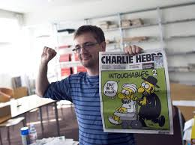](https://www.google.fr/imgres?imgurl=http://referentiel.nouvelobs.com/file/13589153.jpg&imgrefurl=http://tempsreel.nouvelobs.com/charlie-hebdo/20150107.OBS9494/charlie-hebdo-les-representants-religieux-condamnent-l-attentat.html&docid=D8p2_vSmoV0tzM&tbnid=-_zwOD5SeKxMOM:&vet=10ahUKEwj16Njeou_VAhUKKVAKHQSMCAk4ZBAzCEIoPjA-..i&w=819&h=613&itg=1&client=firefox-b&bih=671&biw=1075&q=couverture%20anti-religieuse%20de%20charlie%20hebdo&ved=0ahUKEwj16Njeou_VAhUKKVAKHQSMCAk4ZBAzCEIoPjA-&iact=mrc&uact=8)

[](https://www.google.fr/imgres?imgurl=https://pasidupes.files.wordpress.com/2015/01/blog-charlie-hebdo-1012-amour-plus-fort-que-haine-luz.jpg&imgrefurl=https://pasidupes.wordpress.com/tag/liberte-dexpression/&docid=SKz-7C58xGddWM&tbnid=u2VYWwaHTqeqHM:&vet=10ahUKEwj16Njeou_VAhUKKVAKHQSMCAk4ZBAzCEQoQDBA..i&w=650&h=528&client=firefox-b&bih=671&biw=1075&q=couverture%20anti-religieuse%20de%20charlie%20hebdo&ved=0ahUKEwj16Njeou_VAhUKKVAKHQSMCAk4ZBAzCEQoQDBA&iact=mrc&uact=8)

[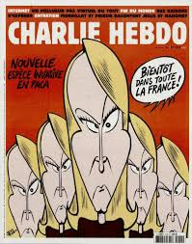](https://www.google.fr/imgres?imgurl=http://pi.ac3j.fr/wp-content/uploads/2015/12/Charlie-Hebdo-1219-2-d%C3%A9cembre-2015.jpg&imgrefurl=http://pi.ac3j.fr/charlie-hebdo-les-unes-de-2015/&docid=nrAOqIvlqTqzxM&tbnid=ILdnyaNMQQOkMM:&vet=10ahUKEwj16Njeou_VAhUKKVAKHQSMCAk4ZBAzCEUoQTBB..i&w=804&h=1024&client=firefox-b&bih=671&biw=1075&q=couverture%20anti-religieuse%20de%20charlie%20hebdo&ved=0ahUKEwj16Njeou_VAhUKKVAKHQSMCAk4ZBAzCEUoQTBB&iact=mrc&uact=8)

[](https://www.google.fr/imgres?imgurl=http://www.slate.fr/sites/default/files/photos/10410718_860230387333434_348741343666688015_n.jpg&imgrefurl=http://www.slate.fr/story/96543/unes-charlie-hebdo&docid=Z7KnHZI-Jnt16M&tbnid=_5-_F82sdzX7EM:&vet=10ahUKEwj16Njeou_VAhUKKVAKHQSMCAk4ZBAzCEgoRDBE..i&w=650&h=957&client=firefox-b&bih=671&biw=1075&q=couverture%20anti-religieuse%20de%20charlie%20hebdo&ved=0ahUKEwj16Njeou_VAhUKKVAKHQSMCAk4ZBAzCEgoRDBE&iact=mrc&uact=8)

[il y a 6 jours](https://www.google.fr/imgres?imgurl=https%3A%2F%2Flookaside.fbsbx.com%2Flookaside%2Fcrawler%2Fmedia%2F%3Fmedia_id%3D1634506023239196&imgrefurl=https%3A%2F%2Ffr-fr.facebook.com%2FCharlieHebdoOfficiel%2F&docid=uxs5aYy5PbkycM&tbnid=cucj8IrZVfmPNM%3A&vet=10ahUKEwj16Njeou_VAhUKKVAKHQSMCAk4ZBAzCEsoRzBH..i&w=823&h=960&client=firefox-b&bih=671&biw=1075&q=couverture%20anti-religieuse%20de%20charlie%20hebdo&ved=0ahUKEwj16Njeou_VAhUKKVAKHQSMCAk4ZBAzCEsoRzBH&iact=mrc&uact=8)

[](https://www.google.fr/imgres?imgurl=http://www.politproductions.com/sites/default/files/img-les_cons_de_dieu-charlie_hebdo_le_diner_de_cons.png&imgrefurl=http://www.politproductions.com/content/les-cons-de-dieu&docid=e_1Y2CfGDlALsM&tbnid=KyuqSoB-i6SLuM:&vet=10ahUKEwj16Njeou_VAhUKKVAKHQSMCAk4ZBAzCFMoTjBO..i&w=651&h=522&client=firefox-b&bih=671&biw=1075&q=couverture%20anti-religieuse%20de%20charlie%20hebdo&ved=0ahUKEwj16Njeou_VAhUKKVAKHQSMCAk4ZBAzCFMoTjBO&iact=mrc&uact=8)

[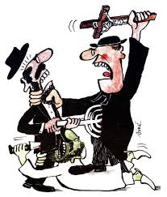](https://www.google.fr/imgres?imgurl=http://media.rtl.fr/online/image/2016/0505/7783114312_chruudruyaa-c2s.jpg&imgrefurl=http://www.rtl.fr/culture/medias-people/en-images-mort-de-sine-ses-dessins-les-plus-marquants-7783114208&docid=hOXk3TPqC7JZYM&tbnid=eFbA53Ur8ZA9CM:&vet=10ahUKEwj16Njeou_VAhUKKVAKHQSMCAk4ZBAzCFcoUjBS..i&w=567&h=665&client=firefox-b&bih=671&biw=1075&q=couverture%20anti-religieuse%20de%20charlie%20hebdo&ved=0ahUKEwj16Njeou_VAhUKKVAKHQSMCAk4ZBAzCFcoUjBS&iact=mrc&uact=8)

[](https://www.google.fr/imgres?imgurl=http://pi.ac3j.fr/wp-content/uploads/2016/11/Charlie-Hebdo-1273-14-decembre-2016.jpg&imgrefurl=http://pi.ac3j.fr/charlie-hebdo-les-unes-2016/&docid=R8M7MyySfDItUM&tbnid=NaJB5386Xs5UsM:&vet=10ahUKEwj16Njeou_VAhUKKVAKHQSMCAk4ZBAzCFgoUzBT..i&w=757&h=960&client=firefox-b&bih=671&biw=1075&q=couverture%20anti-religieuse%20de%20charlie%20hebdo&ved=0ahUKEwj16Njeou_VAhUKKVAKHQSMCAk4ZBAzCFgoUzBT&iact=mrc&uact=8)

[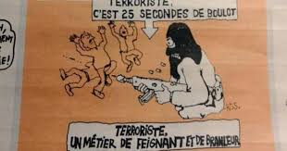](https://www.google.fr/imgres?imgurl=https://o.aolcdn.com/images/dims3/GLOB/legacy_thumbnail/1200x630/format/jpg/quality/85/http://i.huffpost.com/gen/2489160/images/n-CHARLIE-HEBDO-628x314.jpg&imgrefurl=http://www.huffingtonpost.fr/2015/01/14/charlie-hebdo-reactions-14-janvier_n_6467832.html&docid=pmGLwvHQSVeUJM&tbnid=s0fbY07UhsmhOM:&vet=10ahUKEwj16Njeou_VAhUKKVAKHQSMCAk4ZBAzCFooVTBV..i&w=1200&h=630&client=firefox-b&bih=671&biw=1075&q=couverture%20anti-religieuse%20de%20charlie%20hebdo&ved=0ahUKEwj16Njeou_VAhUKKVAKHQSMCAk4ZBAzCFooVTBV&iact=mrc&uact=8)

[](https://www.google.fr/imgres?imgurl=http://media.rtl.fr/online/image/2016/0505/7783114311_chr9plrwmaegcqs.jpg&imgrefurl=http://www.rtl.fr/culture/medias-people/en-images-mort-de-sine-ses-dessins-les-plus-marquants-7783114208&docid=hOXk3TPqC7JZYM&tbnid=VRoacgpZf8k7-M:&vet=10ahUKEwj16Njeou_VAhUKKVAKHQSMCAk4ZBAzCFsoVjBW..i&w=600&h=803&client=firefox-b&bih=671&biw=1075&q=couverture%20anti-religieuse%20de%20charlie%20hebdo&ved=0ahUKEwj16Njeou_VAhUKKVAKHQSMCAk4ZBAzCFsoVjBW&iact=mrc&uact=8)

[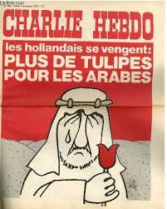](https://www.google.fr/imgres?imgurl=http://www.20min.ch/diashow/117318/117318-tX5tlI_uCOAwEm_4u8OCkw.jpg&imgrefurl=http://www.20min.ch/ro/news/dossier/charlie/story/27765809&docid=D2_HZWGcdtzeSM&tbnid=gp2D4QpK0J7aqM:&vet=10ahUKEwj16Njeou_VAhUKKVAKHQSMCAk4ZBAzCFwoVzBX..i&w=400&h=500&client=firefox-b&bih=671&biw=1075&q=couverture%20anti-religieuse%20de%20charlie%20hebdo&ved=0ahUKEwj16Njeou_VAhUKKVAKHQSMCAk4ZBAzCFwoVzBX&iact=mrc&uact=8)

[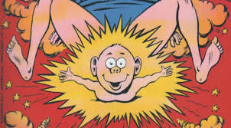](https://www.google.fr/imgres?imgurl=http://static.europe-israel.org/wp-content/uploads/2015/01/Couverture-Charlie-Hebdo-petit-J%C3%A9sus.jpg&imgrefurl=http://www.europe-israel.org/2015/01/regardez-bien-cette-couverture-personne-na-ete-tue-a-cause-delle-charlie-hebdo-avait-fait-fort-pas-sur-lislam-sur-le-catholicisme/&docid=1Tb-m6AVTcbHfM&tbnid=zb7PsyjnwNvrMM:&vet=10ahUKEwj16Njeou_VAhUKKVAKHQSMCAk4ZBAzCGIoXTBd..i&w=778&h=430&client=firefox-b&bih=671&biw=1075&q=couverture%20anti-religieuse%20de%20charlie%20hebdo&ved=0ahUKEwj16Njeou_VAhUKKVAKHQSMCAk4ZBAzCGIoXTBd&iact=mrc&uact=8)

[](https://www.google.fr/imgres?imgurl=https://pasidupes.files.wordpress.com/2015/01/blog-charlie-hebdo-censure-religieuse-monde-c3a0-lenvers-erreur-intellectuelle-dieu-n-existe-pas.jpg&imgrefurl=https://pasidupes.wordpress.com/category/polemique/page/2/&docid=Aw5UFKrScvGOOM&tbnid=xK986p3ix5jjPM:&vet=10ahUKEwj16Njeou_VAhUKKVAKHQSMCAk4ZBAzCGMoXjBe..i&w=366&h=400&client=firefox-b&bih=671&biw=1075&q=couverture%20anti-religieuse%20de%20charlie%20hebdo&ved=0ahUKEwj16Njeou_VAhUKKVAKHQSMCAk4ZBAzCGMoXjBe&iact=mrc&uact=8)

[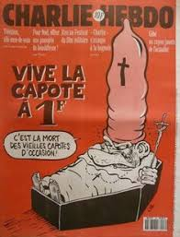](https://www.google.fr/imgres?imgurl=https://s-media-cache-ak0.pinimg.com/236x/46/cd/d7/46cdd78f29a17d356542fe0bcc486cdc--charlie-hebdo.jpg&imgrefurl=https://www.pinterest.com/pin/529454499919833191/&docid=IFNnOlT5rye9tM&tbnid=NVLoJM_Ygm2RwM:&vet=10ahUKEwj16Njeou_VAhUKKVAKHQSMCAk4ZBAzCGUoYDBg..i&w=236&h=309&itg=1&client=firefox-b&bih=671&biw=1075&q=couverture%20anti-religieuse%20de%20charlie%20hebdo&ved=0ahUKEwj16Njeou_VAhUKKVAKHQSMCAk4ZBAzCGUoYDBg&iact=mrc&uact=8)

[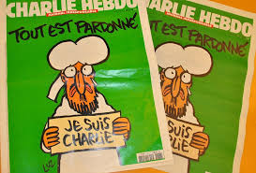](https://www.google.fr/imgres?imgurl=http://md1.libe.com/photo/708180-deux-une-charlie-cadree.jpg?modified_at=1421412662&ratio_x=03&ratio_y=02&width=168&imgrefurl=http://www.liberation.fr/planete/2015/01/17/contre-la-une-de-charlie-hebdo-des-manifestations-parfois-violentes-dans-le-monde-musulman_1182645&docid=tfko8leurpFlNM&tbnid=IkpZSpWVRtepQM:&vet=10ahUKEwj16Njeou_VAhUKKVAKHQSMCAk4ZBAzCGYoYTBh..i&w=975&h=661&client=firefox-b&bih=671&biw=1075&q=couverture%20anti-religieuse%20de%20charlie%20hebdo&ved=0ahUKEwj16Njeou_VAhUKKVAKHQSMCAk4ZBAzCGYoYTBh&iact=mrc&uact=8)